TYPES OF DATA:

We developed three categories of data.

Structured, Semi-Structured and Un-Structured

The **structured data** comes in a standardized format such as row-column table format.

The **semi-structured data** does not obey the tabular structure.

However, it has another well-defined key/value structures such as JSON or XML.

Both of these represent data as key/value elements.

Why semi-structured?

Because they do not have a tabular structure. But they have some key/value structures.

The last category is the **unstructured data**, where we do not see any definite pattern or structure.

The unstructured data comes in text files, pdf and other documents, images, and video files.

**The three V’s**

Volume, Variety, Velocity

So the industry needed a Big Data Management platform to do the following.

Store High Volumes of data arriving at a higher velocity

Accommodate structured, semi-structured, and unstructured data variety

Process high volumes of a variety of data at a higher velocity

**Hadoop**

A Cluster is a group of computers.

And the cluster operating system makes it work like a single large computer.

And that was the first capability of the Hadoop platform.

**Hadoop vs RDBMS:**

Hadoop offers petabyte-scale of data storage.

In contrast, RDBMS was good for storing Terabytes of Data.

Hadoop also offered to store structured, semi-structured, and unstructured data into the Hadoop platform.

In contrast, RDBMS offered only structured and semi-structured data.

The Hadoop platform also offered SQL queries using an additional component called Hive. So we could configure Hive on the Hadoop platform and run SQL queries on the data just like any other RDBMS system.

Hadoop also offered some scripting languages like Apache Pig Scripting.

Hadoop allowed us to code Java data processing applications and offered JDBC/ODBC connectivity.

Hadoop has three parts:

YARN

HDFS

MapReduce

**YARN:**

The YARN stands for Yet Another Resource Manager.

An Operating system allows multiple programs to be in memory and run simultaneously. And this is achieved by sharing resources such as CPU, Memory, and disk I/O. The YARN does the same. It allows multiple applications to run on the Hadoop Cluster and share resources amongst the applications.

Hadoop YARN has three main components:

* Resource Manager
* Node Manager
* Application Master

We created a Hadoop cluster so we can run big data applications.

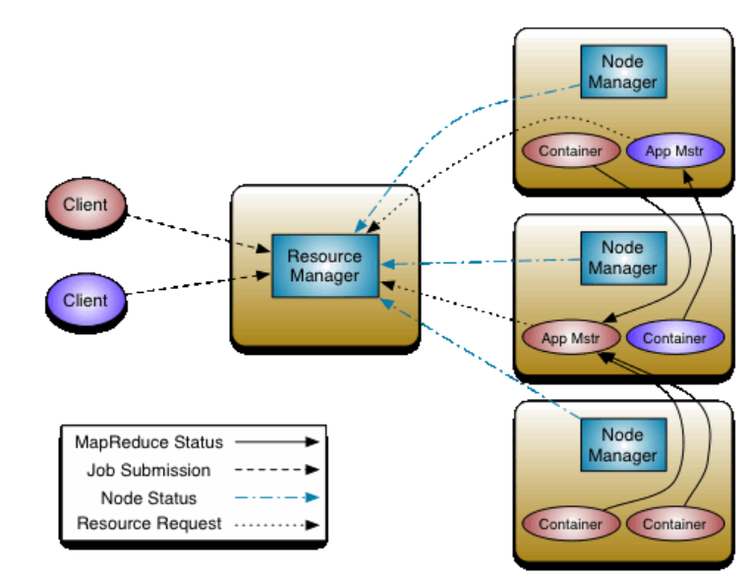

For running an application on Hadoop, you must submit the application to the YARN resource manager. Let us assume you submitted a Java application to the YARN using a command line submit tool.

Now the resource manager should run this application on the cluster.

So, the resource manager will request one of the node managers to start a resource container and run an AM (application master) in the container.

A container is a set of resources that includes memory and CPU.

Each application on YARN runs inside a different AM container.

**HDFS:**

The HDFS stands for Hadoop Distributed File system, and it allows you to save and retrieve data files in the Hadoop Cluster.

The HDFS has the following components.

* Name Node
* Data Node

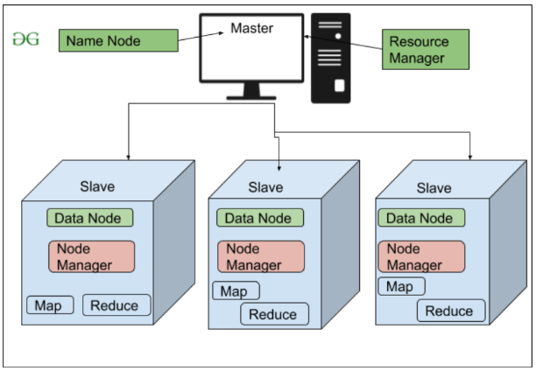  
Hadoop implements a master/worker architecture.

So one node is designated as the master, and the other nodes act as workers.

Hadoop will install the Name Node service on the master. And each worker node runs a data node service. The name node with the data node service forms the HDFS.

The primary purpose of the HDFS is to allow us to save files on this Hadoop cluster

and read them whenever required.

Namenode keeps track of all the metadata.

**MapReduce:**

Map-reduce is a programming model and a framework. A programming model is a technique or a way of solving problems.

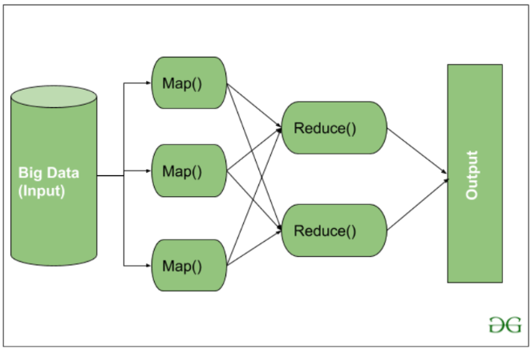

The M/R framework is a set of APIs and services that allow you to apply the map-reduce programming model. Hadoop Map Reduce framework is now outdated and not used anywhere.

**Advantages of Spark over Hive:**

Spark programs worked 10 to 100 times faster than the Hadoop M/R programs.

Like Hive, Spark also offered SQL, but Spark SQL was also 10 to 100 times faster than Hive SQL.

Spark offered the idea of composable functional APIs instead of a complex M/R model. Composable APIs were much simpler to adopt for designing data processing solutions.

Spark supported Java, Scala, Python, and R programming language.

Spark also decoupled the HDFS and started supporting cloud storage such as Amazon S3 and Azure Blob storage.

Spark also removed the dependency on Hadoop YARN.

**DataLake:**

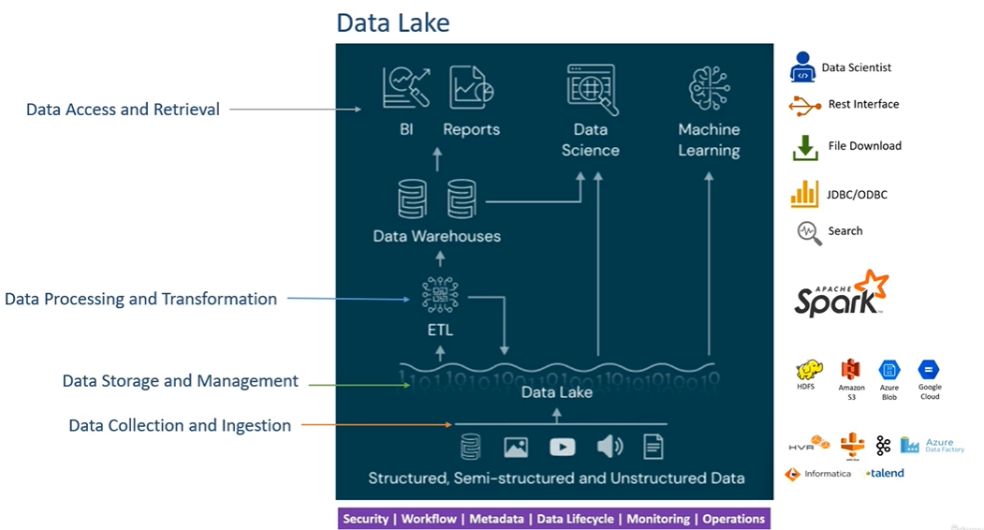

**Apache Spark and Databricks:**

Apache Spark is an open-source project. The original creators of Apache Spark donated it to Apache Foundation and made it an Open Source project. However, that same team formed a company and a commercial product around Apache Spark.

The company and the product are both named Databricks.

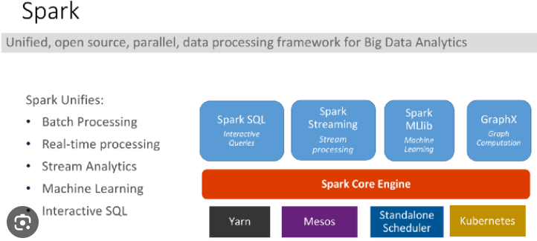

Spark was initially based on Hadoop MR, and it was adopted in the Hadoop platform.

So, the Hadoop YARN resource manager is the most commonly used cluster manager for Spark.

However, you have other options, such as Mesos and Spark Standalone Cluster Manager. The newer versions of Spark are also compatible with Kubernetes as a Cluster Orchestrator.

Databricks brings Apache Spark on all the major cloud platforms.

Databricks allows you to launch a Cluster for running Spark applications automatically.

Databricks allows you to start, configure, and install all the dependency and runtime libraries on all the nodes to run your Spark application.

Spark is a JVM application.

It runs in a Java Virtual machine.

You might write code in Python, but Spark runs most things in a Java Virtual Machine.

So you need JDK on your local machine for installing and running your Spark application.

Section-4 Video 25 Spark Execution Model and architecture

You can run your Spark applications using one of the following methods:

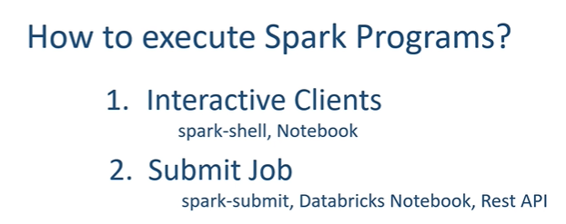

Spark shell and Notebooks are the main interactive tools whereas the Spark Submit is the primary tool for submitting a Spark program to the cluster.

We use interactive clients for learning, development, and exploration. Still, a real-life production implementation is all about packaging your Spark application and submitting it to the cluster for execution. Spark-submit is the most commonly used tool for this purpose.

Spark applies a master-slave architecture to every application.

So, when we submit our application to the Spark, it is going to create a master process for your application. This master process is then going to create a bunch of slaves to distribute the work and complete your job.

In Spark terminology, the **master is a driver**, and the **slaves are the executors**.

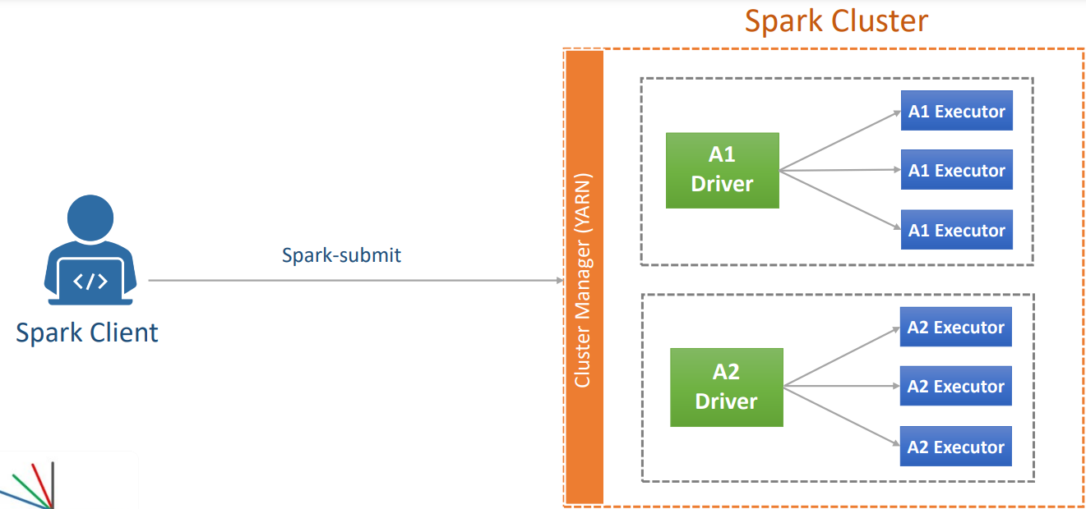

Suppose you are using the spark-submit utility, and you submitted an application A1.

Now Spark engine will request the cluster manager to give a container

and start a driver process for A1.

Once started, the driver will ask for some more containers from the cluster manager and start slave executors.

And that is all. Now your driver and executors are responsible for running your application code and doing the job that you wanted.

Let's assume you submitted one more application, A2. Now the A2 is going to repeat the same. That means the spark engine will request a container and start the A2 driver.

Then the A2 driver is going to ask some more containers and start the A2 executors.

And in all this, A1 and A2 are two independent applications.

Both of them are following a master-salve architecture and have their own dedicated driver and executors.

Two questions-

How Spark runs your application on a local machine when we do not have a cluster

and a cluster manager?

And the next question is about how Spark runs our application when we use interactive tools?

<https://medium.com/@kumar.gaharwar/execution-modes-in-spark-27cd930f66bf>

local:

If you simply say local and do not give any number, then it becomes a single-threaded application. So, when you configure your application to run with a single local thread, then you will have a driver only and no executors.

And in that case, your driver is forced to do everything itself.

Nothing happens in parallel.

However, when you run your application with three local threads, then your application will have one dedicated thread for the driver and two executor threads.

**How Does Spark run with an interactive tool?**

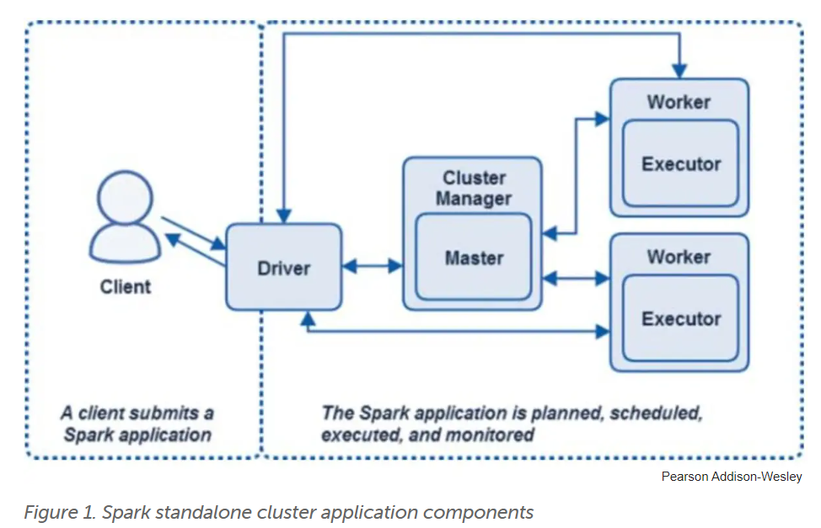

<https://www.infoworld.com/article/3307106/tutorial-spark-application-architecture-and-clusters.html> (Good Article)

Spark gives you a choice to run your application in one of the following modes.

1.)Client Mode

2.)Cluster Mode

In client mode, the driver **runs**on the**client machine**.  
In cluster mode, the driver **runs**on the **cluster**or the**executor**.

The **Client mode** is designed for interactive clients such as spark-shell and the notebooks In this mode, the Spark driver process runs locally at your client machine.

However, the driver still connects to the cluster manager and starts all the executors on the cluster. And this is a powerful feature for submitting interactive queries

and receiving results back to your client. And that is how your spark-shell and the Notebooks are working.

However, if you are quitting your client or you log off from your client machine,

then your driver dies, and hence the executors will also die in the absence of the driver. So, client mode is suitable for interactive work but not for long-running jobs.

The **cluster mode** is designed to submit your application to the cluster and let it run.

In this mode, everything runs on the cluster, your driver, as well as the executors.

Once you submit your application to run in cluster mode, you can log off from the client machine, and your driver is not impacted because it is running on the cluster.

So, the cluster mode is meant for submitting long-running jobs to the cluster.

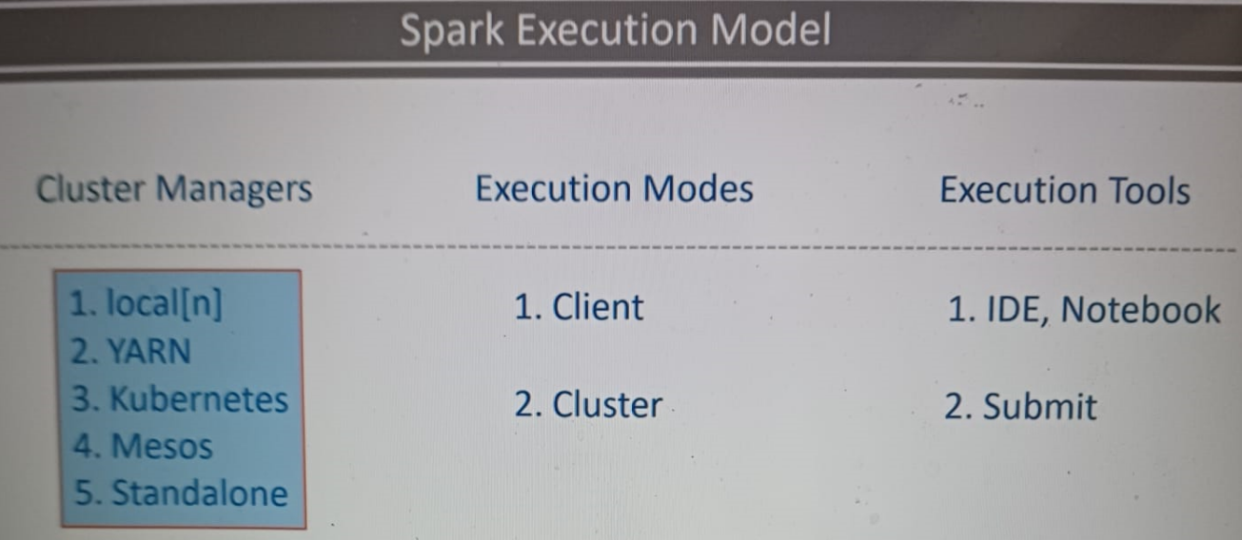

When you are going to run your Spark application, the first thing is to make a decision on which cluster manager you are going to use. There are many options, but in most of the cases, you will be working with two cluster managers-

Local

and YARN

You will be using Local when you are working in your IDE or in a Notebook on your local machine. And you will be using YARN when you are running your Spark application on a real cluster.

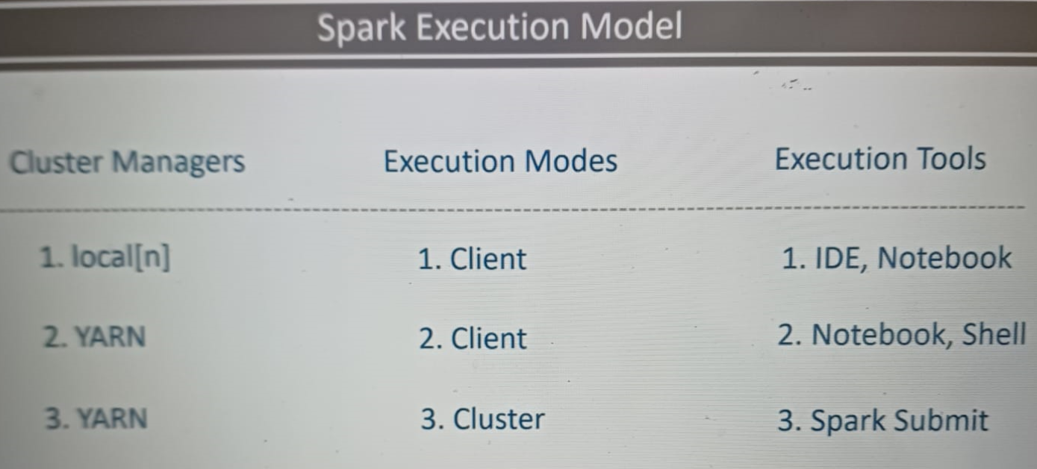

Once you know your cluster manager, then you decide on the execution mode. You already learned that Spark supports two modes. Client Mode and the Cluster Mode

You will be using client mode on your local machine with the local cluster manager. Cluster mode doesn't make any sense here because you do not have a real cluster. You can also use the client mode on the YARN cluster when you are working in a YARN cluster but using a notebook or a spark-shell. Finally, you will be using the cluster mode when you are submitting your Spark application to run on a real cluster.

Log4J

A proper application must have some kind of application logging.

Configuring Log4J for your project is a three-step process.

* Include a Log4J configuration file in your project.
* Configure your Spark to pickup the Log4J configuration file.
* And Finally, create a Python Class to get Spark's Log4J instance and use it in PySpark.

In the most basic setup, the Log4J has got three components.

1. Logger

2. Configurations

3. Appenders

The Logger is the set of APIs which we are going to use from our application.

Configurations are defined in the log4j properties file, and they are loaded by the loggers at runtime.

Appenders are the output destinations, such as Console and a log file.

If you want your YARN manager to collect your application logs,

then you must ensure to create log files in 'spark.yarn.app.container.log.directory.'

This is a variable that YARN is going to use for log collection.

And this configuration should be defined appropriately by your cluster admin.

**Spark-Session**

SparkSession is your driver.

When you start the spark-shell or the notebook, they create a Spark Session for you

and make it available as a variable named spark.

However, when you are writing a spark program, then you must create a SparkSession because it is not already provided. Creating a SparkSession is straightforward.

You will declare a variable and use SparkSession.builder().getOrCreate().

SparkSession is a Singleton object, so each Spark application can have one and only one active spark session. And that makes a perfect sense because the SparkSession is your driver, and you cannot have more than one driver in a spark application.

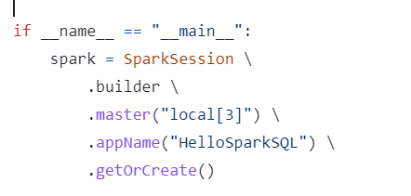

Spark is a highly configurable system, and hence your SparkSession is also highly configurable.

The builder method returns a Builder object, which allows you to configure your SparkSession and finally use the getOrCreate().

Some configurations, such as AppName, and Master are the most commonly used configs by almost every application.

**Spark-config**

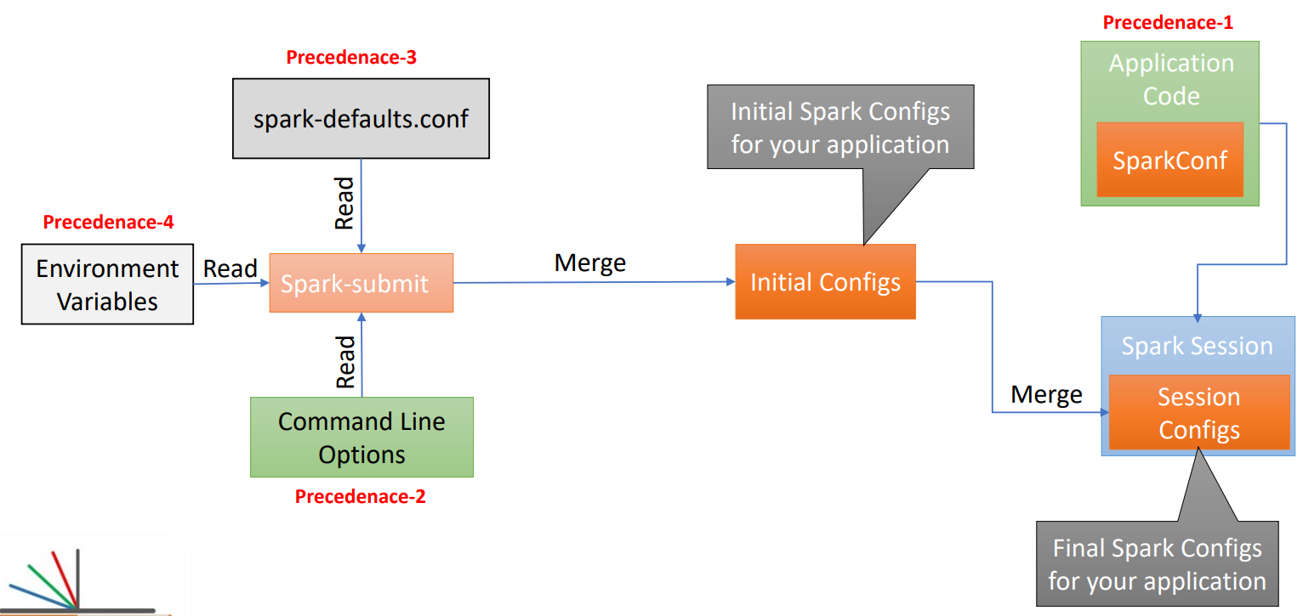

When you run your spark application on your local machine, or you submit it to the Spark cluster,in both the case, your application will read the environment variable, spark-defaults, and the command-line options.Spark will combine all these configs and create a single set of initial configs which go to your application and sit in your Spark Session.

In all this, environment variables are given the lowest precedence, then comes the spark-defaults and finally the command-line options. So, if you have something defined in the spark-defaults and the same config is also set via the command line Spark will overwrite the spark default config with the Spark submit config.

Finally, all these initial configs can be overwritten by you from your application code.

**Spark Dataframe:**

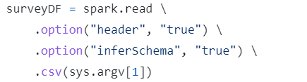

The DataFrame is internally a distributed data structure,and it is composed of a bunch of partitions. However, a Spark programmer can visualize it as a plain DataFrame structure.

And that's what Spark brings to us

- hiding out all the complexities of distributed processing, and we can simply work with a DataFrame as we work with a plain non-distributed data structure.

TRANSFORMATIONS:

Spark DataFrames are immutable.

However, you can give instructions to your driver about what do you want to do and let the driver decide how to achieve it with the help of the executors.

These instructions to the driver are called transformations.

And these transformations could be as simple as some SQL like operations such as select(), filter(), and groupBy().

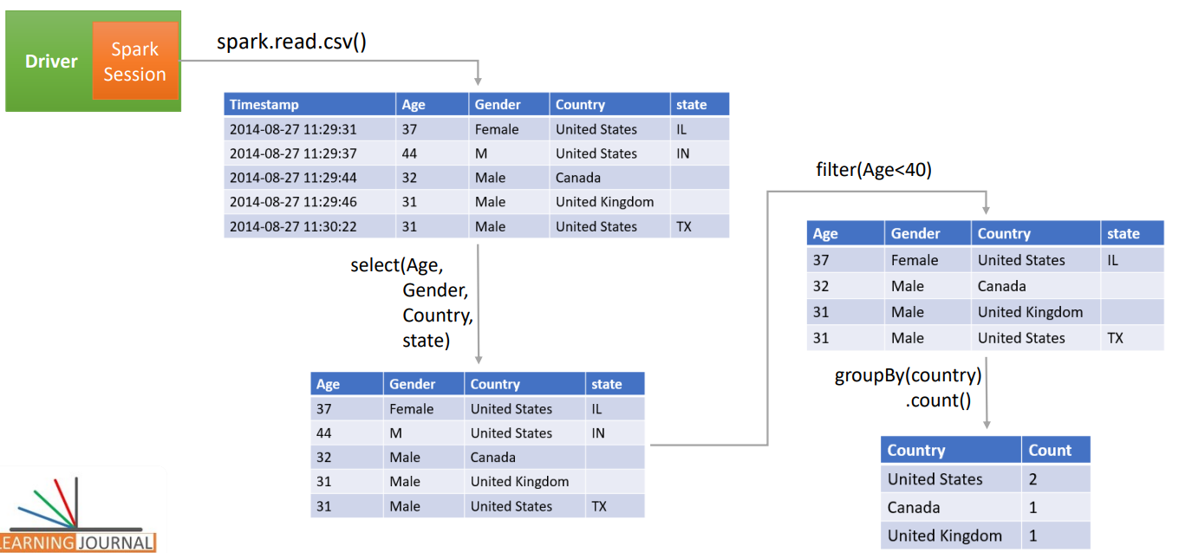

**DAG**:

If you look at all these transformations carefully, you will realize that we are creating a graph of the operations.

Spark data processing is all about creating a DAG of operations.

So all that we are going to do in Spark programming is to create a DAG of activities

And these operations are of two types.

* Transformations
* Actions

Transformations are used to transform one DataFrame into another DataFrame without modifying the original DataFrame.

For example, the where() clause transformation.

It works on the input DataFrame and produces an output DataFrame.

The initial input DataFrame remains immutable.

Spark Transformation is further classified into two types.

* Narrow Dependency Transformation
* Wide Dependency Transformations

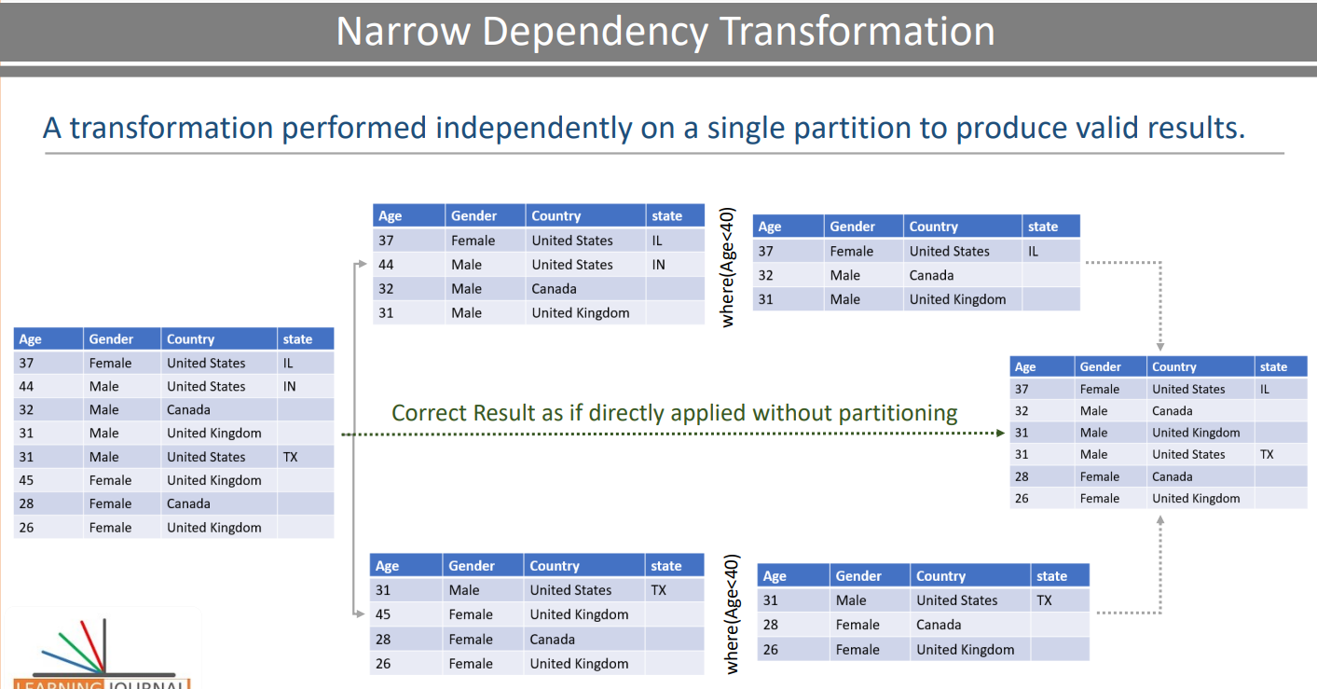

A transformation that can be performed on a single partition and still produce an overall valid result is a Narrow Dependency.

For example, the where() clause transformation is a narrow dependency.

We still get a valid overall result on combining these filtered partitions.

Wide Dependency Transformations

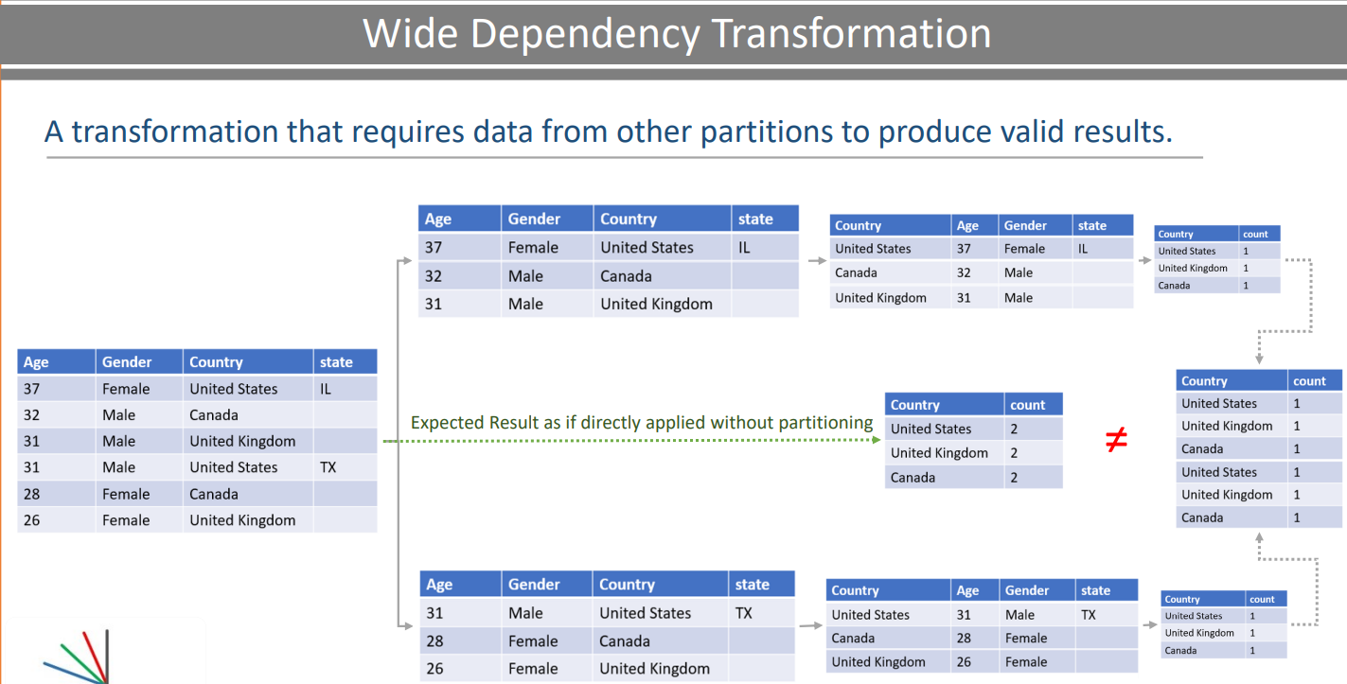

A transformation that requires data from other partitions to produce correct results.

For example a groupBy() transformation.

the GroupBy breaks the independence of a partition. Hence, Any aggregation after the GroupBy will produce incorrect results. And this kind of transformations, such as groupBy is classified as the wide dependency transformation.

Some Spark DataFrame transformations such as GroupBy(), OrderBy(), Join, distinct,

and many others are wide dependency transformations.

**Lazy Evaluations**

Lazy evaluation is a functional programming technique.

A typical programmer is going to look at these transformations as individual statements

that are executed and evaluated line by line.

So you might think of it as read the data, then perform this transformation, then move to the next operation and execute it, and move on line by line.

That's how a typical program runs.

However Spark programs are not going to behave the same.

Because we are using a builder pattern to create a DAG of transformations.

All of this goes to the Spark Driver.

The driver is going to look at these operations, rearrange them to optimize certain activities, and finally create an execution plan which will be executed by the executors.

So these statements are not executed as individual operations, but they are converted into an optimized execution plan which is terminated and triggered by an Action.

What is an Action?

Read, Write, Collect, and Show.

Look at the code.

All of these are transformations because we are transforming one DataFrame into another DataFrame.

SPARK ACTIONS:

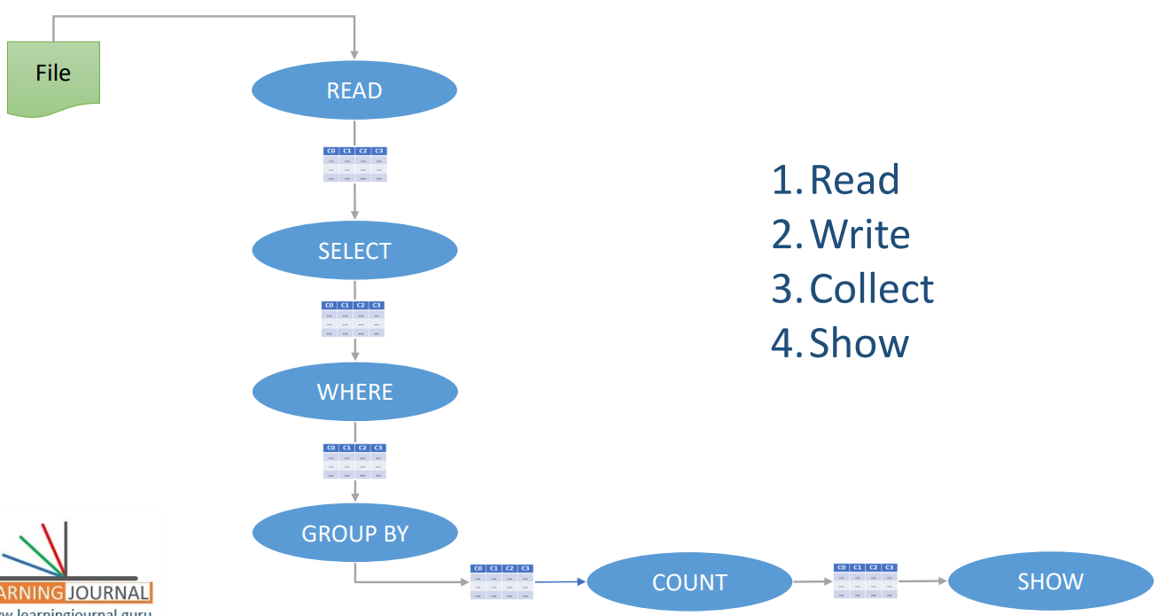

Once we are done, we want to see the result. And you cannot see the result until we execute and finish all of this. So, we need to take action, compute the result, and show it to the console.

Operations that require you to read, write, collect to show the data is an Action.

Loading data into a DataFrame is an action, and every Spark action is translated into a Spark job.

Now every job must have at least one stage, and each stage must have at least one task.

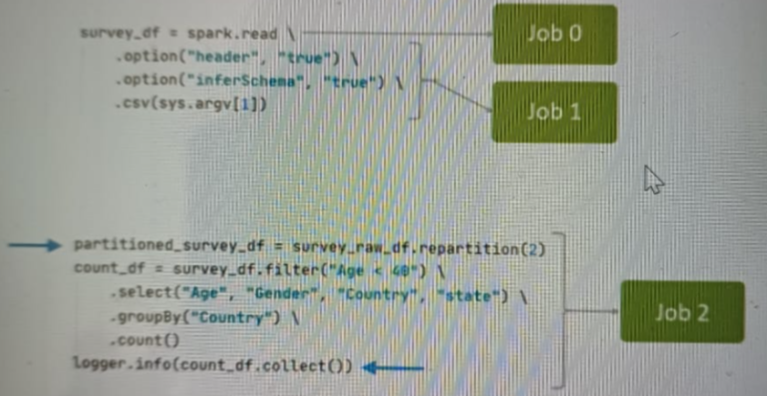

spark is going to look at your code and break it into smaller sections separated by an action.

I have two actions.

Reading a file and collecting the results. Now each section becomes at least one Spark Job. Reading a file and inferring schema are two internal actions.

So, we saw two jobs for this part of the code.

However, collecting the results is a simple action, so I am going to get one job for this section of the code.

Spark will create a DAG for each job and break it into stages separated by a shuffle operation.

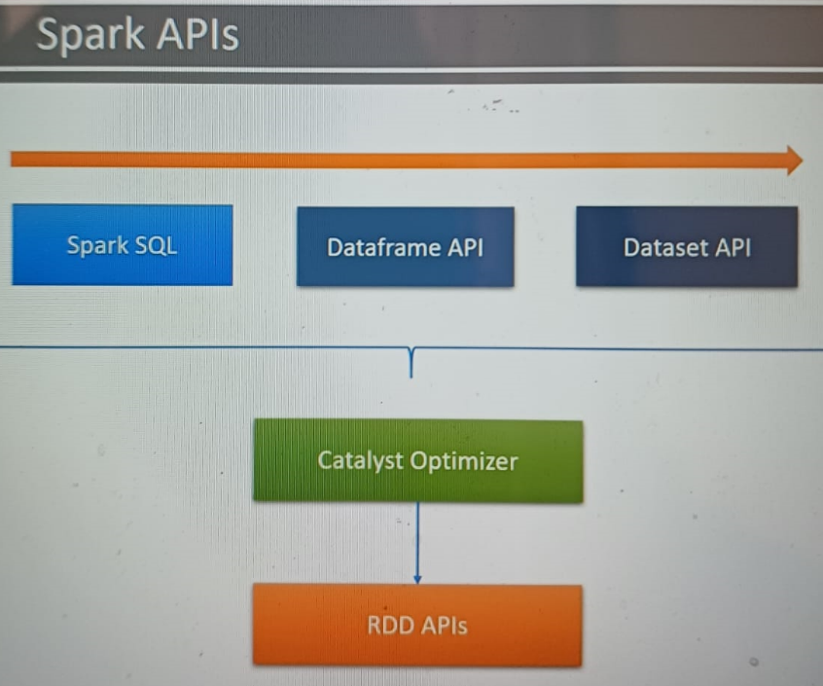

Apache Spark started with the goal of simplifying and improving the Hadoop Map/Reduce programming model. To achieve this goal, Spark came up with the idea of RDD - Resilient Distributed Dataset. The notion of RDD was revolutionary,and it created the core foundation of Apache Spark. However, Spark didn't stop at the RDD and came up with a higher level of APIs such asDataset APIs and DataFrame APIs. To simplify our life, they also came up with the Â SQL layer and a catalyst optimizer. So, all these Spark data processing tools can be visually arranged as the following figure.

The RDD is at the core. You can use RDD APIs to develop your applications. However, it is the most challenging tool to learn and use. They offer you some additional flexibility, but they lack all the optimization brought to you by the catalyst optimizer. I will give you some more details about RDD in a separate video and help you get a reasonable understanding of the RDDs. However, the Spark community is not recommending to use RDD APIs.

The next one is the catalyst optimizer. So we write code using Spark SQL, DataFrame APIs, and Dataset APIs. This code is then submitted to Spark for execution. However, the code passes through the Catalyst Optimizer, which decides how it should be executed and lays out an execution plan.

Finally, the Spark SQL, DataFrame APIs,and Dataset APIs are your preferred choices.

Spark SQL is the most convenient option to use. So, you should prefer using it wherever applicable. Spark SQL is excellent,and it can do a lot of the work for you. However, a single SQL expression or even a SQL script with a series of SQLs may not be helpful in many scenarios. You do not get some necessary facilities like debugging,implementing application logs, unit testing,and other obvious capabilities that a programming language brings on the table. So you will be using Spark SQL to catch some low hanging fruits.

However, a sophisticated data pipeline is going to push you to use DataFrame APIs and rely more on your favorite programming language. And that's where the DataFrame APIs are your obvious choice.

The last one is the Dataset API.The Dataset APIs are the language-native APIs in Scala and Java. APIs are strongly typed objects in your JVM based language such as Scala. And they are not at all available in dynamically typed languages such as Python.

RDD

The idea of Transformations and Actions are the same for the RDDs. However, RDDs offered only basic transformations such as map(), reduce(), filter(), foreach() etc. Most of the RDD transformations were designed to accept a lambda function and simply apply your custom code to the RDD. So basically, the RDD API leaves all the responsibility in the developer's hand. You need to take care of giving a structure to your data, implement your operations, create an optimized data structure, compress your objects, and a lot of other things.

The DataFrame APIs improved the situation by offering some commonly used SQL like operations such as select(), where(), groupBy(), etc.

<https://medium.com/@sangeethadevarajan14/apache-spark-rdd-ccc4f4b85f63>

SPARK SQL:

The most convenient method to use Spark is via Spark SQL.   
The SQL() method takes your Spark SQL expression and returns a DataFrame.

If you know SQL, this approach could be easy to learn and the fastest method to meet your requirements.

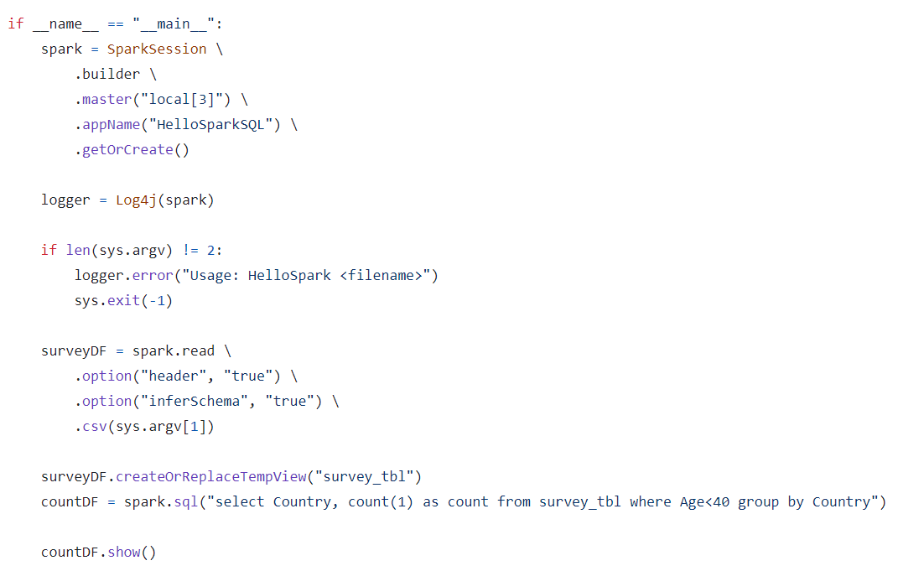

NEW ADDITIONS TO THE COURSE

A typical Spark application, we read data from a source, process it, and write or present the results.

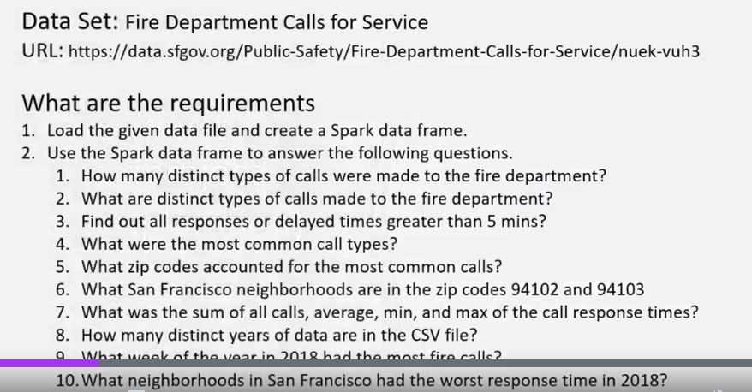

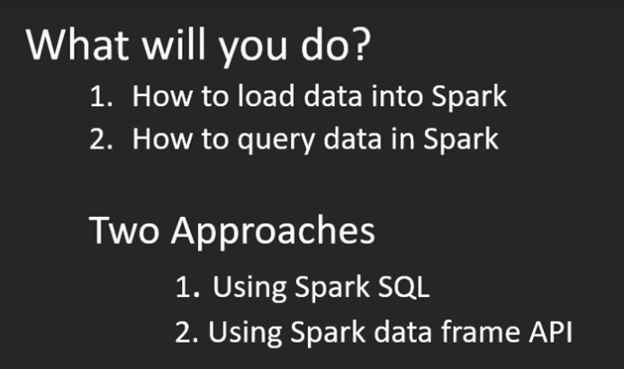

Databases are the most popular and most widely used data processing platforms.

They offer two things at a high level.

* Tables
* SQL

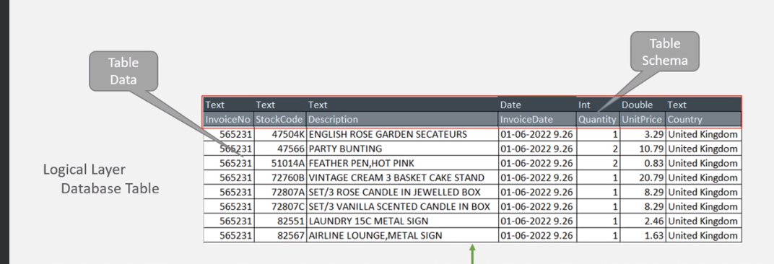

Table Schema- It is a list of column names and data types.

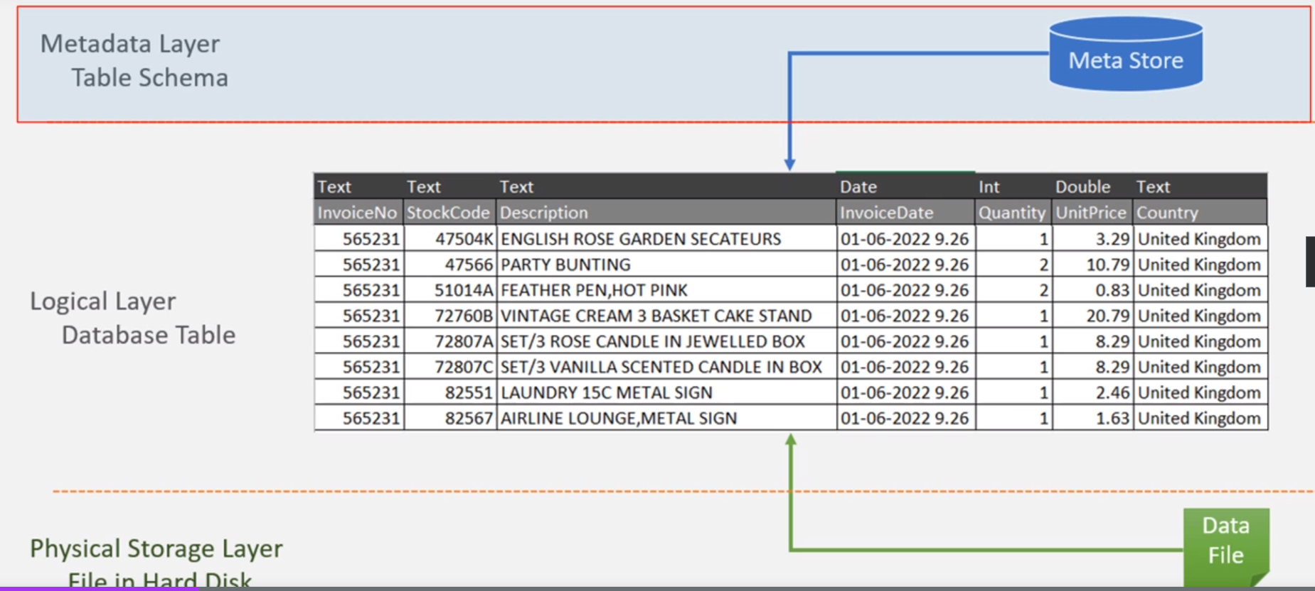

This is how a table is organized. We have three layers to form a table. Storage layer stores the table data in a file. Metadata layer stores the table schema and other important information.

The Logical layer presents you with a database table, and you can execute SQL queries on the logical table.

The DBF file format and database engine were designed to support structured data.

But Spark is designed to support a variety of file formats, and hence you can store and process a variety of data formats.

So what is a Spark Dataframe?

It is the same as the table without a metadata store.

Spark Dataframe is structurally the same as the table.

However, it does not store any schema information in the metadata store.

Instead, we have a runtime metadata catalog to store the dataframe schema information. The catalog is similar to the metadata store, but Spark will create it at the runtime to store schema information in the catalog.

This catalog is only valid until your application is running.

Spark will delete this catalog when your Spark application terminates.

Why create a runtime metadata catalog?

2 reasons for this.

* Spark Dataframe is a runtime object.
* Spark Dataframe supports schema-on-read.

You can create a Spark Data frame at runtime and keep it in memory until your program terminates. Once your program terminates, your dataframe is gone.

It is an in-memory object.

Spark tables are permanent. Once created, you will have a table forever.

You can drop a table and remove it. But it remains in the system until you drop the table.

However, Spark Dataframe is a runtime and temporary object which lives in Spark memory and goes away when the application terminates.

So, the metadata is also stored in the temporary metadata catalog.

The second reason is due to the schema-on-read feature.

We define a schema for the table when creating a table. Then we load data into the table. The data must comply with the table schema, or you will get an error.

However, Dataframe is different. We load the data into a Dataframe and tell the schema when loading the data. And Spark will read the file, apply the schema at the time of reading, create the Dataframe using the schema and load the data.

So a Dataframe is always loaded with some data, whereas a Table can be empty.

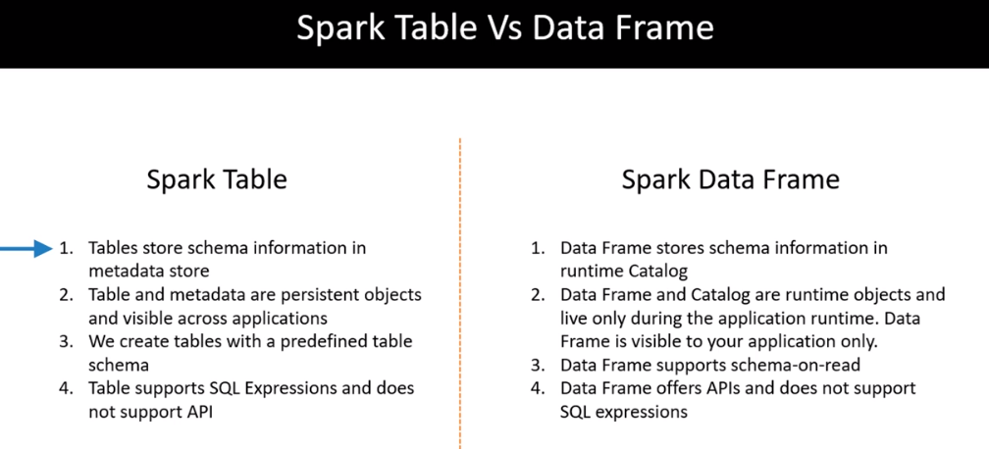



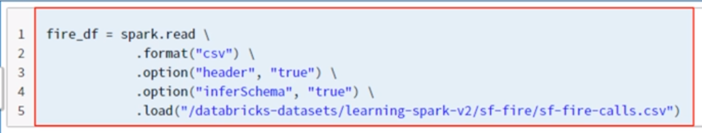

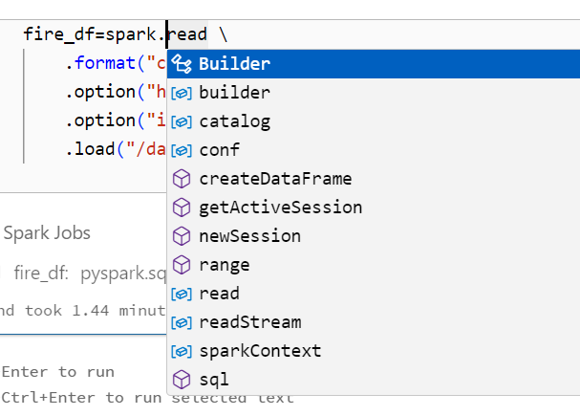

The spark here is a Spark Session object. Spark session is your entry point for the Spark programming APIs. Every Spark program starts with the Spark Session

because Spark APIs are available to you via the Spark Session object.

We have Builder, Catalog, conf, and many more items. So spark is a SparkSession object, and all these are either attributes or methods of the spark session object.

We want to use the read attribute. The read is an attribute of the spark session object, and that's why we do not use parenthesis after the read attribute.

The read attribute gives you a DataframeReader object.

So the first line of code spark.read gives you a DataframeReader.

The rest of the code, such as format, option, and load, are the methods of the DataframeReader.

I am telling the DataframeReader that the data file is a CSV file.

Then I am telling that the CSV file comes with a header row.

I am also saying that the DataframeReader should infer schema from the file itself.

Finally, I call the load method so the DataframeReader can load the file from the given location.

DOCUMENTATION-

<https://spark.apache.org/docs/latest/api/python/reference/index.html>

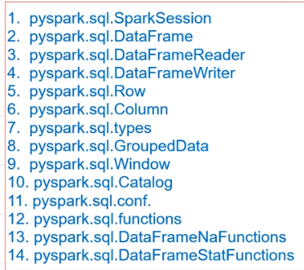

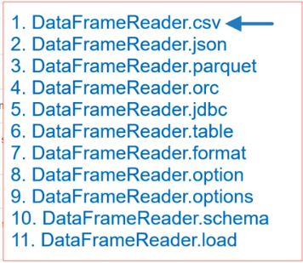

If you look at this list, we have the first six methods to load data from different sources.

The first method is for loading data from a CSV file.The second one is for loading JSON files.

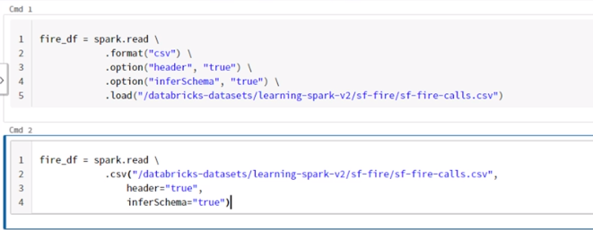

So what is the difference between these two code blocks?

We are doing the same thing.

The CSV method is a shortcut method.

I am not setting the format and options.

The CSV method implicitly tells that the format is CSV, and all other details will go as function arguments.

This long-form method(1st method) is preferred because this code is standardized for loading data from any file format.

<https://spark.apache.org/docs/latest/api/python/reference/pyspark.sql/api/pyspark.sql.DataFrame.html?highlight=dataframe#pyspark.sql.DataFrame>

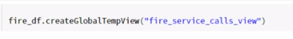

I am taking my dataframe and creating a global-temporary view for the dataframe.

The view name is fire_service_calls_view.

I am not converting my Dataframe to a table.

Instead, I am creating a global-temporary view that is similar to the table.

I can run SQL expression on this view.

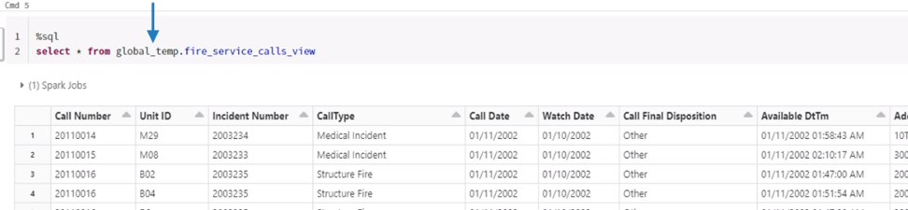

The global_temp is a hidden database, and all global temporary tables are created in this global_temp database.

So you must use global_temp for accessing a global-temporary view.

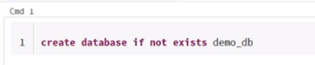

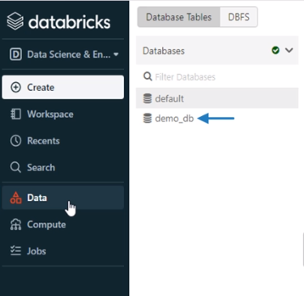

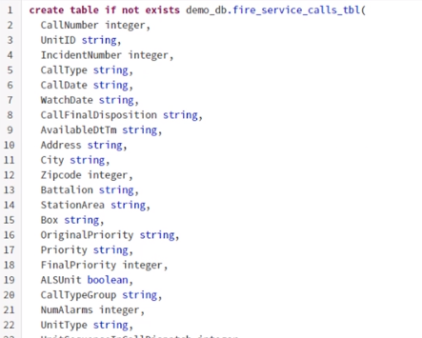

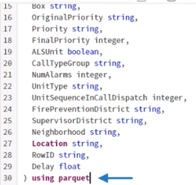

Every database table internally stores data in files. So for this table, I want Spark to use parquet file format.



So how do we insert data into the table?

You can use the insert-into command to insert some records into the table in a traditional database table.

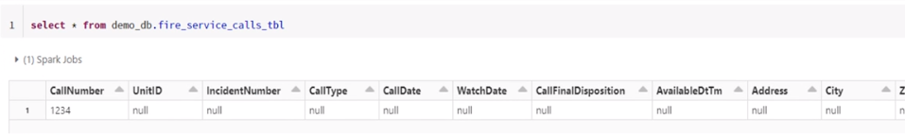

The insert into values expression doesn't make much sense in the big data world.

You will not find a project that uses insert into values to load data into Spark tables.

Then how do we load data into Spark tables?

There are many ways.

But for now, we will insert records into the table from another table.



The first thing is to truncate the table, so we clean the garbage record that we just inserted.

Why truncate? Why not delete?

Because Spark SQL doesn't offer to delete statements.

You cannot delete data from a Spark Table using Spark SQL.

(Databricks does offer a delete expression on Spark tables)

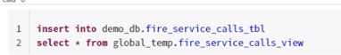

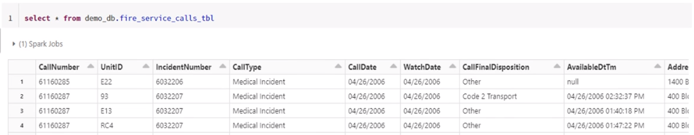

DOCUMENTATION-

<https://spark.apache.org/docs/latest/sql-ref-syntax.html>

Databricks community edition will terminate your cluster after 2 hours of idle time.

Once your cluster is terminated, Databricks will clean up the following things.

Cluster VM and Spark Metadata Store

So your compute and metadata layers are permanently gone. Databricks will clean up the cluster VM so you cannot restart it again. Databricks will also clean up the Spark Metadata store. So you will lose your databases and tables.

But you can create a new cluster for your learning purposes.

This problem does not exist for the full licensed version of the Databricks Cloud.

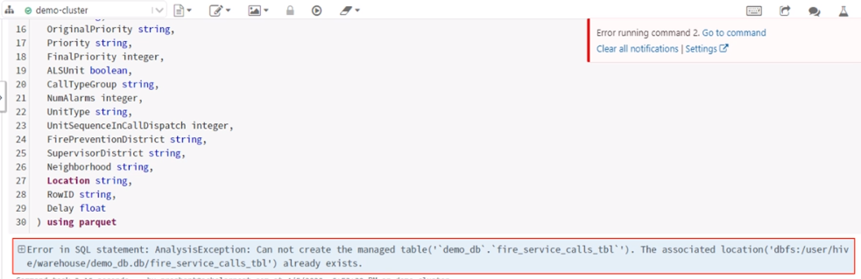

The community edition will clean up the VM and the metadata store. But it doesn't clean up the directories and files. So you do not lose your storage layer. Your data files remain in place even if your compute and metadata layer is gone. Directories are created in an external distributed storage, and files are stored in these directories on external storage. The external storage is not part of the cluster.

So even if your cluster is terminated, VM is cleaned, metadata is flushed, but your data files still remain in place.

How to fix this problem?

We can manually clean the directory and the data file.

Add a new cell at the top of the notebook and type the filesystem rm command to clean the directory.



We will use the %fs rm -r command to delete a directory and all its content.

But which directory do you want to delete?

Look at the error message and copy the directory location from there.

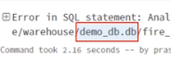

So we want to delete demo_db.db directory.

This one is the home directory for my database.

So I must clean it before I recreate the table for my new cluster.

Do not delete the warehouse directory. That's the default location for all Spark databases. So you should not touch the warehouse directory. Instead, you should delete your database directory only.

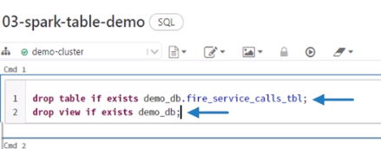

Two sql expressions in one cell so must put semicolon

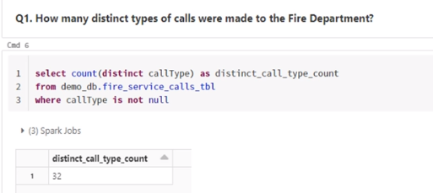

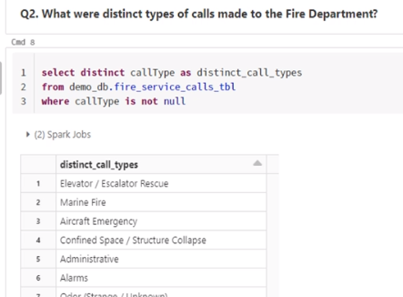

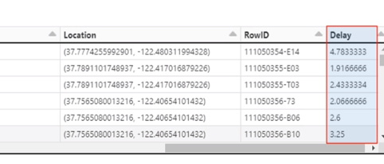

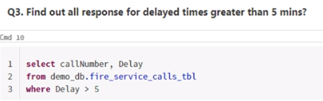

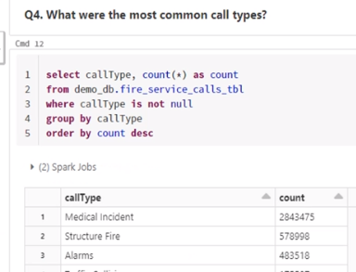

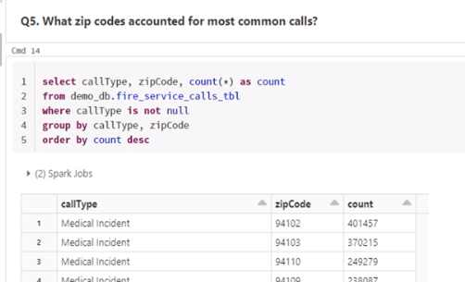

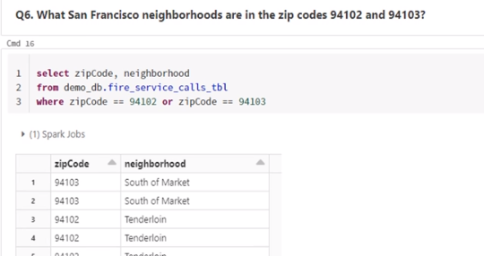

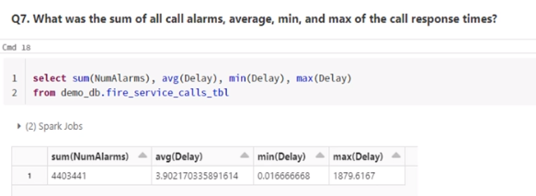

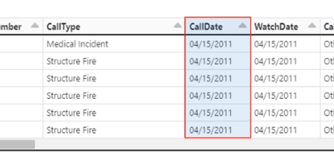

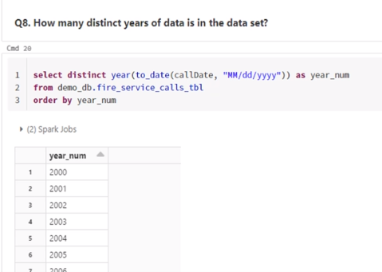

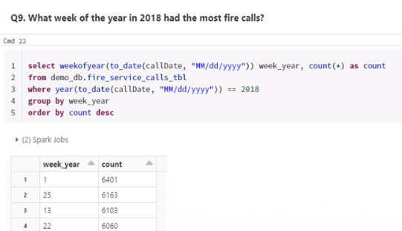

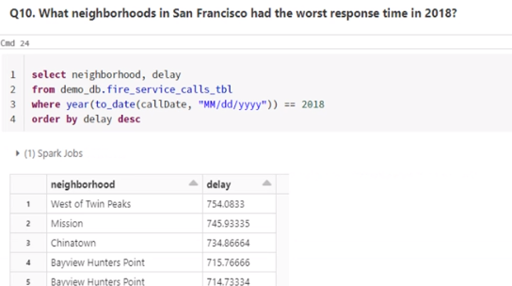

<https://spark.apache.org/docs/latest/api/python/reference/pyspark.sql/api/pyspark.sql.DataFrame.html?highlight=pyspark%20sql%20dataframe#pyspark.sql.DataFrame>

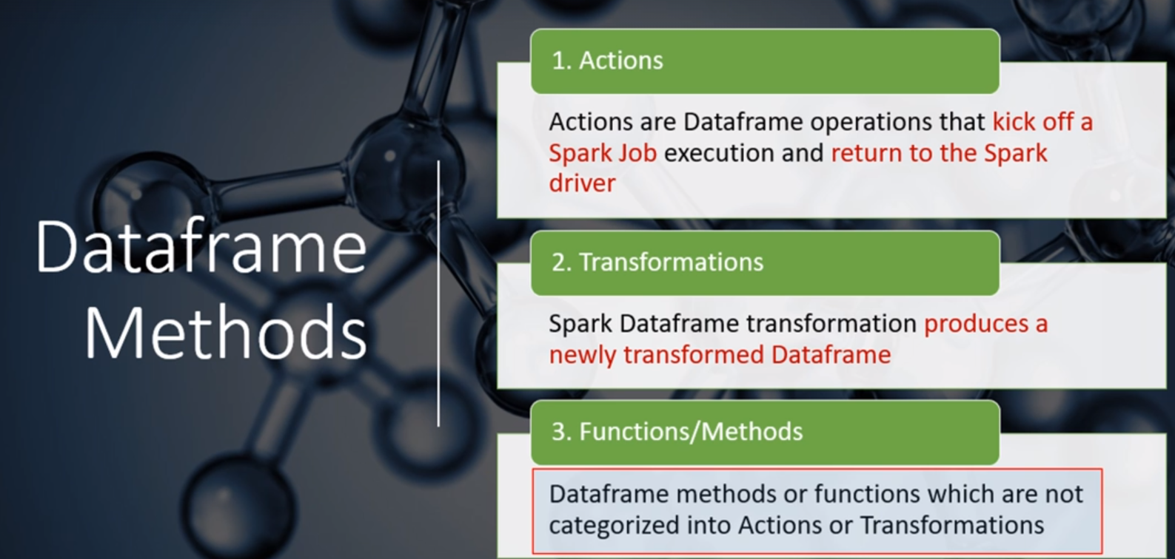

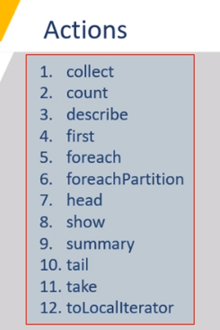

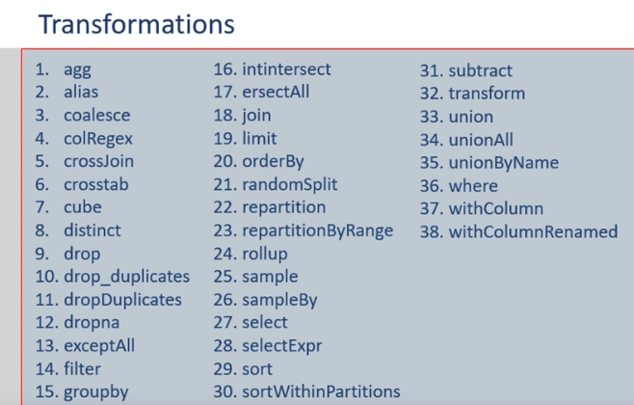

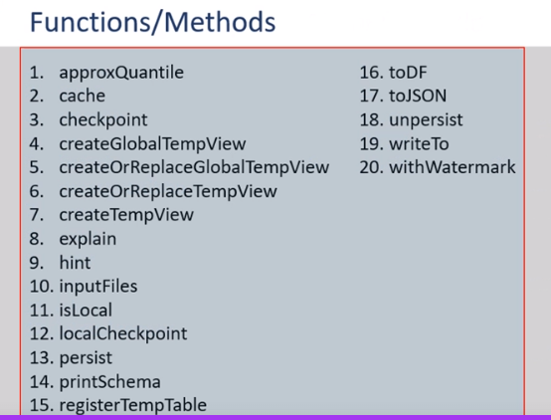

10 more functions exclusive to Python and not frequently used-

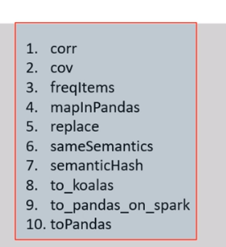

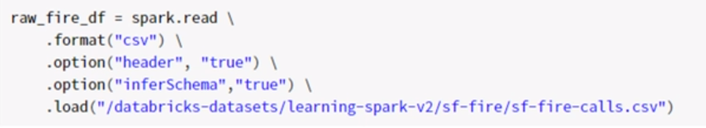

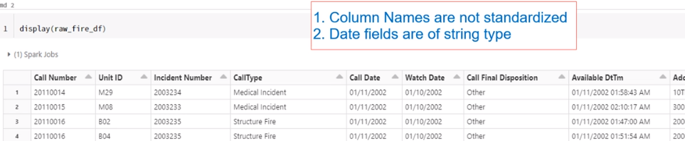

Spark dataframe column names are case insensitive. So upper case or lower case column names are the same. However, space in a column name is not a common thing. We have spaces in many column names for this dataframe.

We should fix these column names and rename them to remove spaces.

We can use the withColumnRenamed() transformation to rename the column and remove the space.

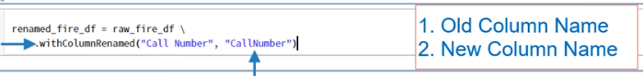

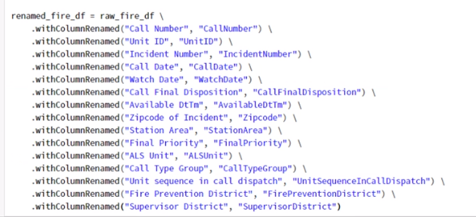

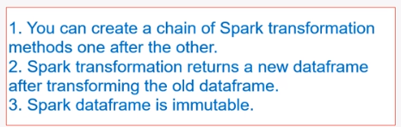

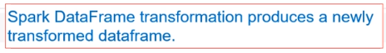

You can see the data type information using the printSchema() utility method.

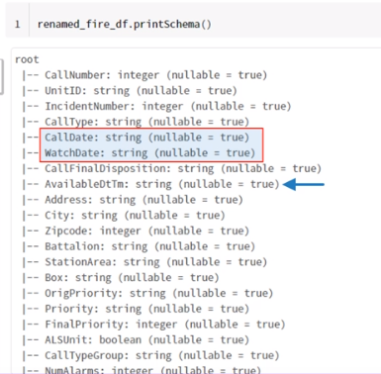

If your date and timestamp fields are stored in a string column, you may have to convert it to date on almost every use of the column.

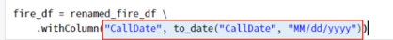

The withColumn() transformation converts only one column in the given dataframe.

It takes two arguments: the column name and the conversion logic.

This code will change the CallDate column to a data type and return a new dataframe.

I save the new dataframe as fire_df.

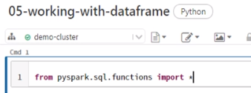

I am using to_date() function here. So I must import this function from the pyspark.sql.functions package.

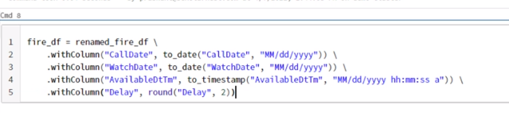

The Delay column represents call response delay in minutes. We have six digits in this field. But I wanted to fix the values up to two digits

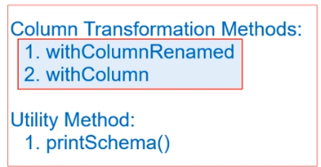

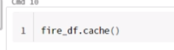

It will cache the dataframe into memory.

Why do I want to cache this dataframe?

Because I want to run ten analysis transformations on the same dataframe.

So it makes sense to cache the dataframe in memory and speed up my analysis execution.

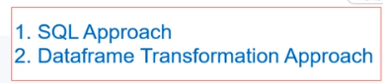

The SQL Approach is a two step process-

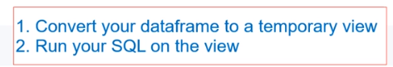

The createOrReplaceTempView() is a utility method, and it takes the view name as an argument.

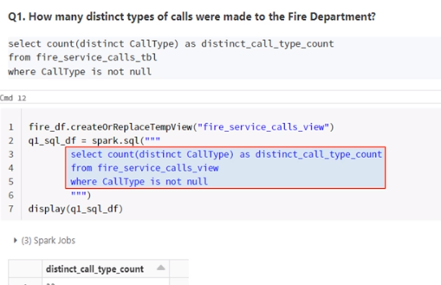

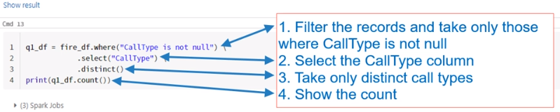

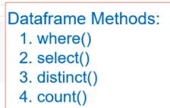

The first three are transformations and return a dataframe where as count() is an action

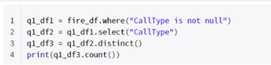

(Same code written differently)

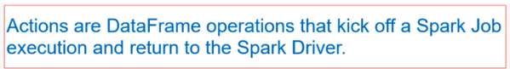

The best practice recommendation is to keep an Action on a separate line.

Why?

Let everyone know that we cannot chain anything after we call an action.

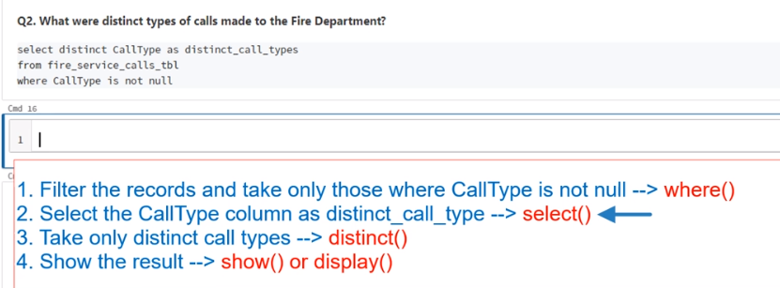

The select transformation takes a column name.

It doesn't take an expression. If you want to use an expression in the select() method, you must evaluate your expression using the expr() function.

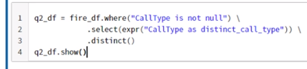

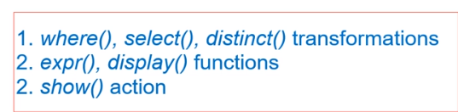

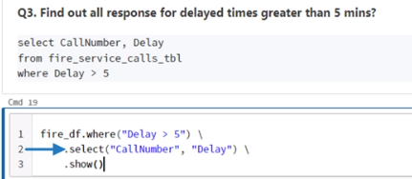

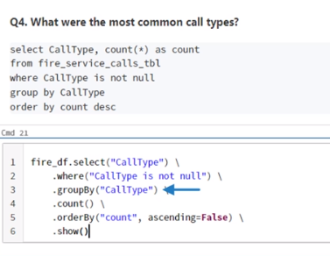

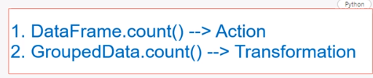

If you are using a count before the groupBy(), it will be an action, and you cannot chain any other transformation after the count() Action.

However, if you use a count() method after the groupBy(), it will be a transformation,

and you can chain further transformations.

**Spark Data Sources/Sinks:**

Spark is used for processing large volumes of data.

Any processing engine, including Spark, must-read data from some data source.

And that's what we mean by Spark Data Sources. These data sources can be further categorized into two groups:

* External Data Sources
* Internal Data Sources

Your data might be stored in some source systems such as Oracle or SQL Server Databases. It might be stored at some application servers, such as your application logs. However, all these systems are external to your Data Lake.

The list of possible external data sources is too long. However, here are some notable systems:

* JDBC Data Sources such as Oracle, SQL Server, MySQL, PostgreSQL etc.
* No SQL Data Systems such as Cassandra, MongoDB
* Cloud Data Warehouses such as Snowflake, Redshift
* Stream Integrators such as Kafka

How can we read data from external sources to Spark?

You cannot process the data from these systems unless you read them

and create a Spark DataFrame or a Dataset.

There are two approaches:

The first approach is to bring your data to the Data Lake and store them in your Lake's distributed storage.

The second approach is to use Spark Data Source API to directly connect with these external systems. And Spark allows you to do it for a variety of source systems.

**Internal Data Sources**

So your internal data source is your distributed storage. It could be HDFS or cloud-based storage.

What is the Data Sink?

The data sinks are the final destination of the processed data.

So you are going to load the data from an internal or an external source. Then you will be handling it using the Spark APIs. Once your processing is complete, you want to save the outcome to an internal or an external system. And these systems could be a data file in your data lake storage, or it could be an external system such as a JDBC database, or a NoSQL database.

Working with the data source is all about reading the data, and working with the sink is about writing the data.

Spark allows you to read data using the DataFrameReader API.

You can access the DataFrameReader through the SparkSession via the read method.

SPARK DOCUMENTATION:

<https://spark.apache.org/docs/latest/api/python/reference/index.html>

**PySpark Data Types and Schema:**

DataFrame schema is all about setting the column name and appropriate data types.

Apache Spark comes with its own data types.

<https://spark.apache.org/docs/latest/api/python/reference/pyspark.sql/data_types.html>

Spark allows you to define Schema in two ways.

Programmatically

and Using DDL String

The second method is is much simpler and easier.

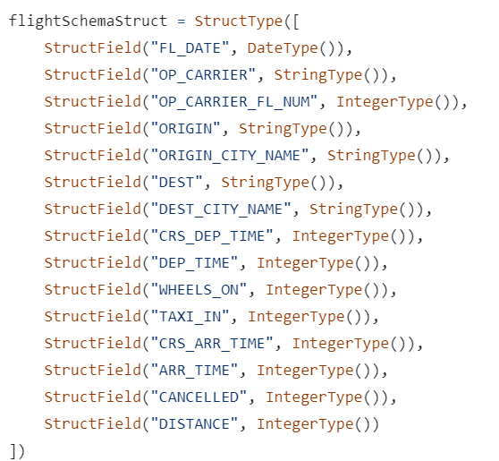

CSV:

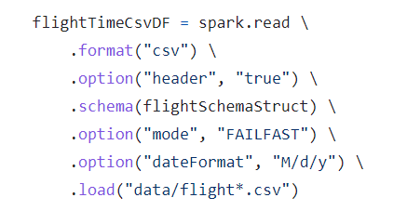

CSV file comes with a header, so let me set the header to true.

Then I specify the file path.The path could be a file name,or it could be a directory location. Spark DataFrameReader is going to read all the files in the given directory.

USING DDL:

The Schema DDL is straightforward.

All you need is the column name and data type separated by a comma.

And you can use this Schema in the same way as a Programmatically defined schema.

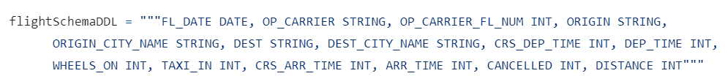

JSON:

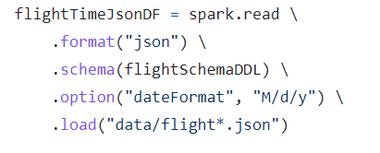

The JSON format will always infer the schema, and you do not need to give this option.

PARQUET:

The parquet is a binary file format which comes with the schema information already included in the data file. So, you do not need to specify the schema explicitly.

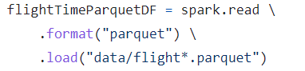

You should prefer using the Parquet file format as far as it is possible.

And the parquet file format is the recommended and the default file format for Apache Spark. Your data integration tools might bring the original data source in CSV or in JSON format. However, if you have a choice, then you must be trying to get your data in the Parquet file format. And most of the data integration tools are now supporting to create parquet files.

Spark allows you to write data using DataFrameWriter API.

The DataFrameWriter is a standardized API to work with a variety of internal and external data sources.

The first and the most important thing is the output format.

Spark supports a bunch of internal file formats such as CSV, JSON, Parquet, AVRO, ORC, etc.

However, Parquet is the default file format.

So, DataFrameWriter assumes Parquet when you do not specify the format.

The next thing is to specify the options.

Every data sink has a specific set of options to determine how the DataFrameWriter is going to write the data.

However, at a minimum, you must specify the target of your DataFrame.

For a file-based data sink, such as Parquet, it should be a directory location.

The next one is the save mode. Save modes specifies what will happen when Spark existing finds data at the specified location.

We have four valid modes.

The append mode will create new files without touching the existing data at the given location

The overwrite will remove the existing data files and create new files

errorIfExists, will throw an error when you already have some data at the specified location

The ignore will write the data if and only if the target directory is empty and do nothing if some files already exist at the location.

Partitioning:

DataFrames are partitioned.

So, when you write your DataFrame to the file system, you are going to get one output file per partition. That's the default behavior, and it is perfectly fine because each partition is written by an executor core in parallel.

Three ways to partition:

* DataFrame.repartition()
* partitionBy()
* Bucketing

The **first option** is to do the Simple Repartitioning and you already learned it.

You can use the DataFrame.repartition() transformation. This transformation will repartition your data, and you can control the number of output files. However, this could be a blind repartitioning.

The **second option** is to use a partitionBy() method. The partitionBy() method will repartition your data based on a key column. You can use a single column key such as country code, or you can use a composite column key such as country code plus state code.

Key-based partitioning is a powerful method to break your data logically.

It also helps to improve your Spark SQL performance using the partition pruning technique.

The **third option** is to partition your data into a fixed number of predefined buckets.

And this is known as bucketing. You can use the bucketBy() method. However, the bucketBy() is only available on Spark managed tables.

The sortBy() method is commonly used with the bucketBy().

This option allows you to create sorted buckets.

MaxRecordsPerFile is an option that allows you to limit the number of records per file.

You can use this option with or without partitionBy().

Basically, the maxRecordsPerFile helps you to control the file size based on the number of records

and protect you from creating huge and inefficient files.

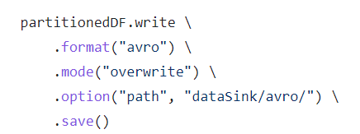

This code is going to create one or more Avro files in the given directory.

However, before writing to the directory location, this API call is also going to clean up the target directory because we are working in overwrite mode.

The save() method in an overwrite mode is a two-step process.

Clean the directory

Write the new files.

No. of Avro files depends upon the number of DataFrame partitions.

**Spark Database and Tables:**

Apache Spark is not only a set of APIs and a processing engine.It is a database in itself.

So you can create a database in Spark.

Once you have a database, you can create database tables and views. These tables and views reside inside your database.

The table has got two parts.

* Table Data
* Table Metadata

The table data still resides as data files in your distributed storage.However, you can control the file type.

The metadata is stored in a meta-store called catalog. The meta-store holds the information about the table and its data, such as schema, table name, database name, column names, partitions, the physical location where the actual data resides.

All of this is stored in a central meta-store called catalog.

By default, Spark comes with an in-memory catalog which is maintained per spark session. However, this information goes away when the session ends.

So, we needed a persistent and durable meta-store. Spark decided to reuse the Apache Hive meta-store.

Spark allows you to create two types of tables

* Managed Tables
* Unmanaged Tables (External Tables)

MANAGED TABLES:

For managed tables, Spark manages both: the metadata and the data.

If you create a managed table, then the Spark is going to do two things:

Create and store metadata about the table in the meta-store.

Then Spark is going to write the data inside a predefined directory location.

This directory is known as the spark.sql.warehouse.dir. So the spark.sql.warehouse.dir is the base location where all your managed tables are stored.

And your cluster admin is going to set this base directory location for you.

You cannot and should not change it at runtime.

UNMANAGED TABLES.

They are also the same with respect to the metadata.

However, they are different in terms of data storage location.

When you create an unmanaged table, the Spark is going to do only one thing.

It will create metadata for your table and store it in the meta-store.

However, when you create an unmanaged table, then you must specify the data directory location for your table.

You do not have this facility with the managed table.

Because the managed table must be stored inside the warehouse directory.

However, unmanaged tables are to give you the flexibility to store your data at your preferred location.

If you drop your managed table, Spark is going to delete the metadata and the data as well.

If you drop an unmanaged table, then Spark is going to remove the metadata and do not touch the data files.

And that makes sense as well. Because the unmanaged tables are designed for temporarily mapping your existing data and using it in Spark SQL.

Once you are done using it, drop them, and only metadata goes off, leaving your data files untouched.

We prefer using managed tables because they offer some additional features such as bucketing and sorting. All the future improvements in Spark SQL will also target managed tables.

Unmanaged tables are external tables, and Spark does not have enough control over them. They are designed for reusing the existing data in Spark SQL, and it should be used in those scenarios only.

<https://sparkbyexamples.com/spark/spark-types-of-tables-and-views/>

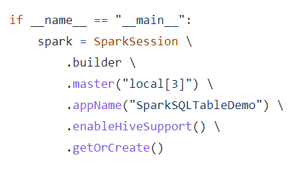

We want to use the Hive Metastore, so I am going to enable hive support.

This is needed to allow the connectivity to a persistent Hive Metastore.

We are trying to create a managed table and save the DataFrame to the Spark Table.

Why save DataFrame as a managed table and not as Parquet or Avro?

You can save your processed data to a data file such as Parquet or Avro.

However, if you want to re-access it, then you must use the DataFrame Reader API and read it as a DataFrame.

However, Spark is a database also. So if you create a managed table in a Spark database,then your data is available to a whole lot of other SQL compliant tools.

Spark database tables can be accessed using SQL expressions over JDBC/ODBC connectors. So, you can use other third-party tools such as Tableau, Talend, PowerBI,

and a whole bunch of other tools. However, plain data files such as Parquet, Avro, JSON, CSV, etc. are not accessible through JDBC/ODBC interface.

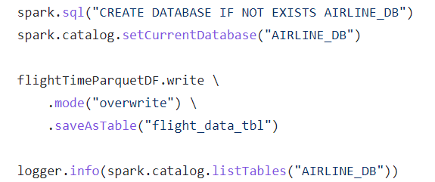

The saveAsTable() method takes the table name,and it creates a managed table in the current spark database.

Apache Spark comes with one default database. The database name itself is the default.

So, the SaveAsTable() is going to create my flight_data_tbl in the default database.

However, I wanted to create this table in the AIRLINE_DB.

Two options are there to deal with this:

1.) Prefix the database name with your table name.

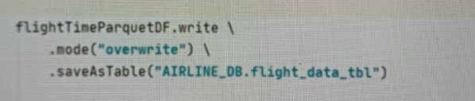

2.) The second option is to access the catalog and set the current database for this session.

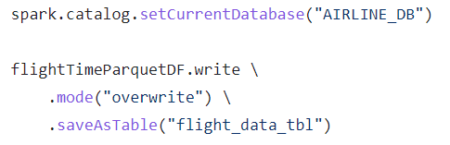

You should not be partitioning your data for a column that has got too many unique values.

Instead, you can use the bucketBy().

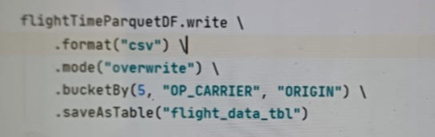

The bucketBy() allows you to restrict the number of partitions. Here Partitions have been limited to 5. So, these five partitions are now called buckets. And I still want to partition my data using the same two columns.

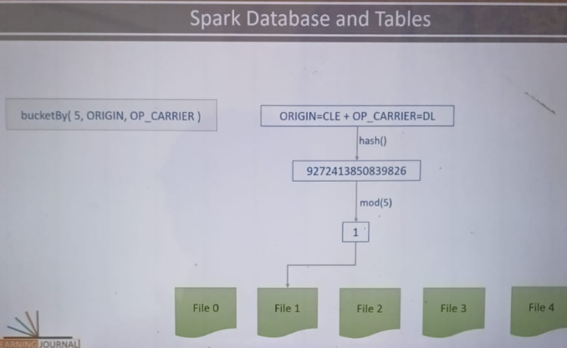

I asked to create five buckets. So Spark created five files.

Each file is one bucket. Now Spark will read one record, look at the key column values.

In my case, it is the OP_CARRIER+ORIGIN. Now compute the hash value. Let's say you got some hash number. Divide it by five and take the remainder. You are going to get something between 0 to 4. If the remainder is 0, place the record in the first file.

If you got 1, put it in the second file and so on.

These buckets can improve your join operations significantly.

However, if these records are sorted, they could be much more ready to use for certain operations. So the bucketBy() can also have a sortBy() companion.

**Introduction to Transformations:**

So, In Spark, we read the data and create one of the two things.

* DataFrames
* Database Tables

Both of these are the same but two different interfaces.The DataFrame is the programmatic interface for your data,and the database table is the SQL interface of your data.

What do we mean by transformations?

* Combining one or more DataFrames using operations such as Join and Union
* Aggregating and summarizing your DataFrames using operations such as grouping, windowing, and rollups
* Applying functions and built-in transformations on your DataFrame such as filtering, sorting, splitting, sampling, and finding unique.
* Using and implementing built-in functions, column-level functions, and user-defined functions
* Referencing Rows/Columns and creating custom expressions

The actual data of a DataFrame is sitting at the executor The DataFrame is just a reference to the real data.

You cannot assert the DataFrame. If you want to validate the data, then you must bring it to the driver.

How? Simple. Collect it.

The collect() method will return List[Row] to your driver.

Once your data is at the driver, you can assert it.

You can iterate over the rows.

Each iteration will give you a Row, and I am going to assert the Row.

So, I am validating it for an isInstanceOf[Date].

**Reading Unstructured Data and converting to Dataframe**

Example File having Unstructured Data:

(This is an Apache logs file)

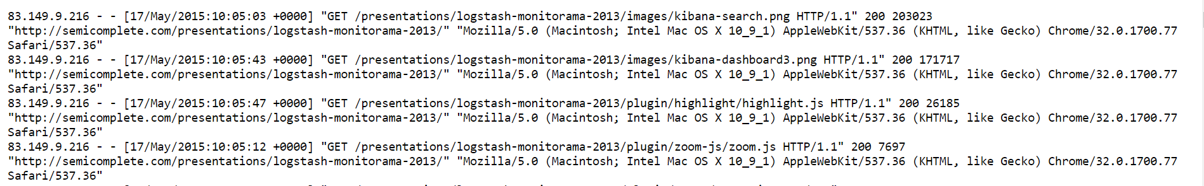

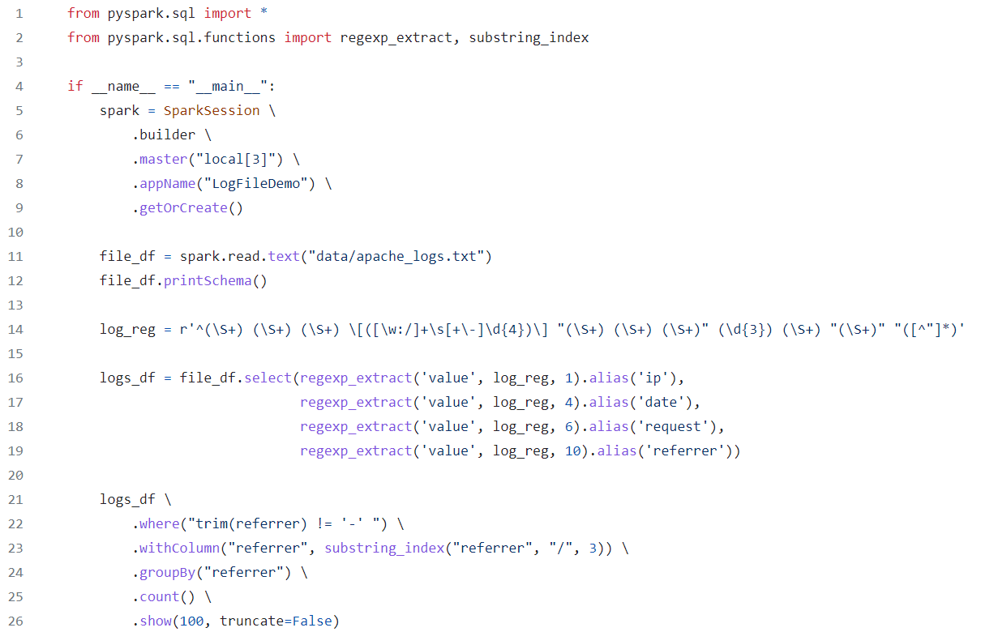

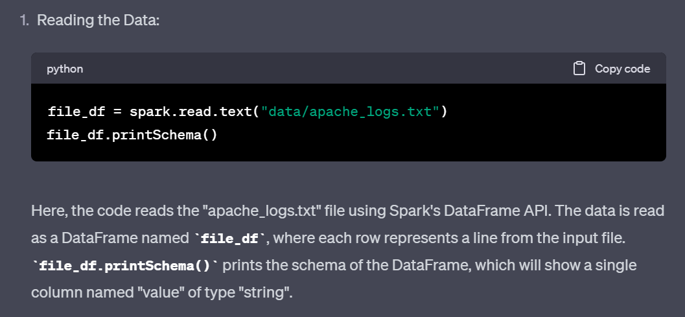

2.Regular Expression:

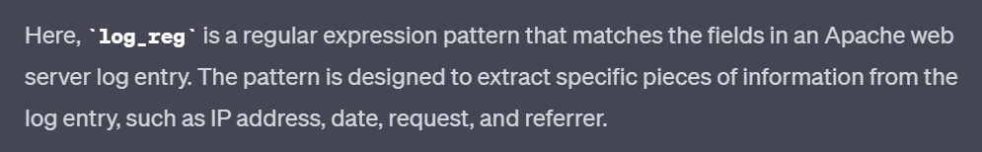

The Regular Expression:



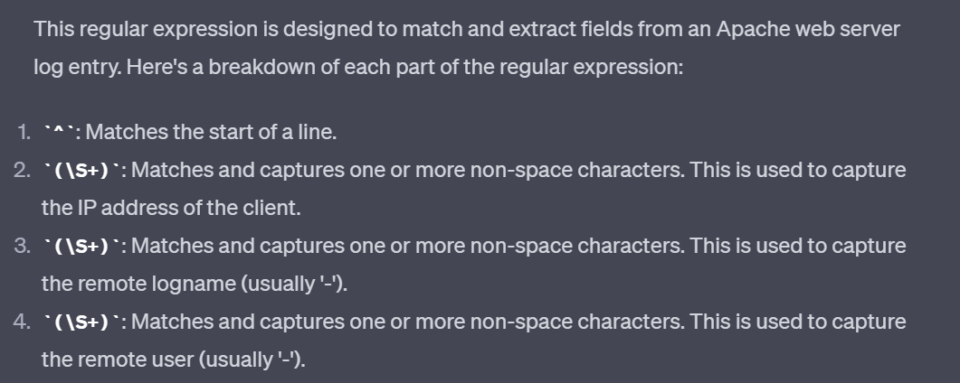

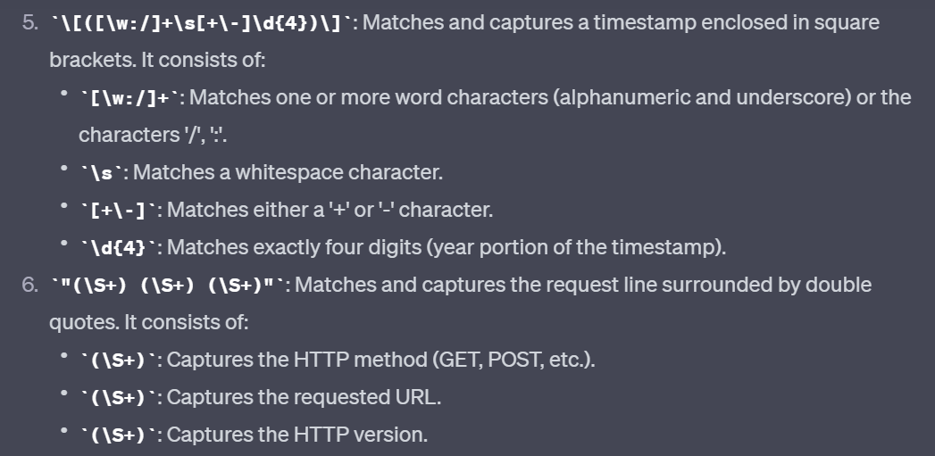

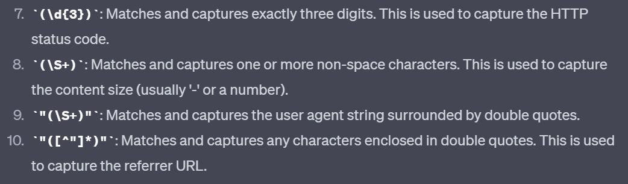

3.) Extracting Fields from Log Data:

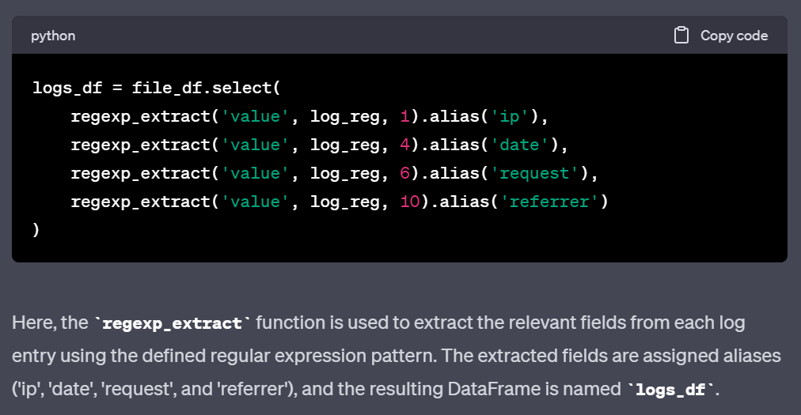

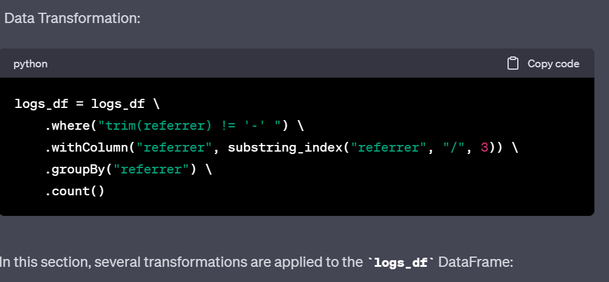

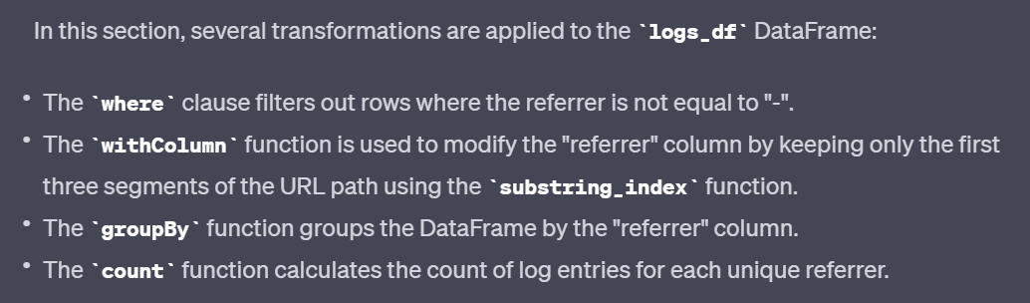

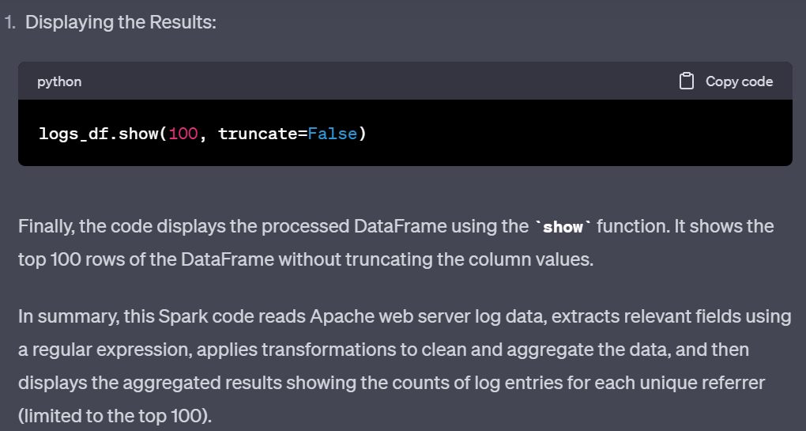

Columns:

Lec 52.

<https://github.com/LearningJournal/Spark-Programming-In-Python/blob/master/10-ExploringColumns/ColumnsNotebook.ipynb>

**UDF:**

Suppose we create our own function parseGender() to modify some column in our dataframe. To use this function:

We can create an expression and use it.

However, we have two approaches to develop the expression

* Column Object Expression
* String Expression

The withColumn() transformation allows you to transform a single column

without impacting other columns in the Dataframe.

It takes two arguments. The first argument is the column name that you want to transform (Gender column). The next argument is a column expression.

So, what I want to do is to use the parseGender() function and supply the Gender column.

However, we cannot simply use a function in a Column Object Expression.

I need to register my custom function to the driver and make it a UDF.

Let me do it.

parse_gender_udf = udf(parse_gender, returnType=StringType())

survey_df2 = survey_df.withColumn("Gender", parse_gender_udf("Gender"))

I am going to use the UDF() function to register it.

So, let me import the functions.

Now, I can use the UDF function to register my Python function using the name of my local function.

You can also specify the return type of your function. The default return type is StringType. So, the return type is optional if your function returns a String.

TWO WAYS TO REGISTER UDF:



This is to register your function as a Dataframe UDF. This method will not register the UDF in the catalog. It will only create a UDF and serialize the function to the executors.



This second type of UDF registration is to register it as a SQL function.

This one will also create one entry in the catalog if you want to use your function in a SQL expression, then you must register it like this.



We use spark-catalog and get a list of all functions in the catalog.

Then we loop through the list. And check if the parse gender is there in the function name.

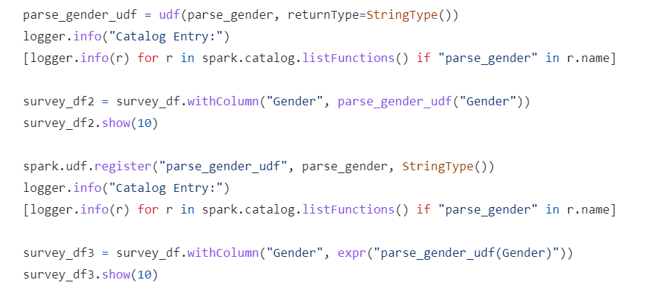

Some more Miscellaneous info:

<https://github.com/LearningJournal/Spark-Programming-In-Python/blob/master/12-MiscDemoNotebook/MiscDemo.ipynb>

Aggregations in Apache Spark:

Aggregations can be classified into three broad categories.

* Simple Aggregations
* Grouping Aggregations
* Windowing Aggregations and summarization

What is the difference between count(*) and count(1)?

The answer is - Nothing.

In Spark, they both work in the same way and give the same answer.

No difference at all.

However, counting a column field has a difference.

So, the count(*) and count(1) will count all the rows even if you have null values in all the columns. However count(col_name) will not count the null values.

Window Partition used to calculate running sum.For Window Partition we need three things:

* Partition
* Ordering
* And the window start/end.

unboundedPreceding means to take all the rows from the beginning.

However, you can give any numeric value here.

For example, If I can give -2 as the start of the window.

So, the window will now start from the two rows before the current row.

The end of the window is the current row.

So, you will be calculating the running total for a three-week window.

**JOINS**

Joins are all about bringing together two data frames. And these two data frames are termed as a left data frame and the right data frame. It is up to you to decide which one do you want to make left and which one to take as the right data frame.

We combine these left and right data frames using two things

* The join condition or the join expression.
* The join type

Default join is inner.

<https://github.com/LearningJournal/Spark-Programming-In-Python/blob/master/17-SparkJoinDemo/SparkJoinDemo.py>

Types of JOINS  
Inner, Outer, Left, Right

The coalesce() function will take the first non-null value from the given list of columns.

Optimizing JOINS

Joining two Dataframes can bring the following two scenarios-

You are joining a **large data frame with another large data frame.**

When we say large, we mean large enough to not to fit into the memory of a single executor.

The second scenario is to join a **large Dataframe with a small** or tiny data frame.

We consider it small when the Dataframe can fit into the memory of a single executor.

Filter out as much data as possible

A large Dataframe to a large Dataframe join is always going to go for a shuffle join. We do not have any other option. However, a large Dataframe join with a small dataframe can take advantage of the broadcast join,

which often works faster than the shuffle join.

If you have two datasets that you already know you are going to join in the future,

then it is advisable to bucket both of your datasets using your join key.

Bucketing your dataset may also require a shuffle.

However, that shuffle is needed only once when you create your bucket.

Once you have a bucket, you can join these datasets without a shuffle, and you can do it as many times as you need.